

**Faculty of Science, School of Natural Sciences**

**Evolutionary divergence and functional investigation of NAMLAA amidases – bacterial proteins essential to cell division**

Sophie Rose Allen

MSc Bioinformatics (Part-Time, 2023-2024)

Birkbeck, University of London

August 2024

Project Supervisor: Dr. Mark Williams

Word Count: 10,057

# Declaration of originality

I confirm that the submitted research is my own, and this has not previously been submitted elsewhere for assessment. Where applicable, I have clearly referenced and cited all material published elsewhere and acknowledged all tools used during the conduct of this research using the Bioinformatics style of referencing.



Sophie Rose Allen

# Abstract

**Background**

N-acetylmuramoyl-L-alanine amidases (NAMLAA) are present across the bacterial kingdom, and have previously been shown to have involvement in cleavage of peptidoglycan and lysis of the septal ring in separation of gram-negative bacteria. However, the presence of NAMLAA in other species of bacteria indicates multiple functions for these amidases. This work seeks to explore the evolutionary divergence of NAMLAA, identify structural differences associated with different bacterial species, and investigate alternative functional roles for NAMLAA.

**Methods**

Through database searching in PDB, RefSeq, and InterPro, a candidate shortlist of experimental NAMLAA structures and sequences was collated. Sequences were used to generate a multiple sequence alignment using kalign-3, which was validated using a separate alignment of experimental structures. Boundaries of regions of low conservation were identified and used to cluster the sequences according to similar structures. Clusters were visualised using PCA and used produce a representative phylogenetic tree. Finally, structures were predicted using AlphaFold3 for a selection of sequences from each cluster, and regions of low conservation mapped onto these.

**Results**

19 candidate structures and 20,304 candidate sequences were identified. A validated sequence alignment 399 residues in length was generated and used to define 5 insertion regions (I-X) distinguishing gram-negative (I-6 and I-7) and gram-positive (I-2 and I-4) bacteria, as well as cluster key genera. I-6 and I-7 in predicted structures validate previous findings in gram-negative bacteria of an auto-inhibitory helix which blocks the active site and is moved upon enzyme activation. I-2 and I-4 structures show similarity to activated NAMLAA structures and cluster genera involved in bacterial sporulation.

**Conclusion**

The structural differences between NAMLAA demonstrate clustering and association with bacterial evolution, and the differences between gram-negative and gram-positive NAMLAA suggest the possibility of alternative functional roles in gram-positive bacteria, such as in spore germination.

# Acknowledgements

Molecular graphics and analyses performed with UCSF Chimera, developed by the Resource for Biocomputing, Visualization, and Informatics at the University of California, San Francisco, with support from NIH P41-GM103311.

I would like to thank and acknowledge my supervisor Dr Mark Williams for his assistance and continued feedback throughout this project to guide both tool suggestions and the direction of analysis. The project and the experience gained has provided me with both the confidence and ability to carry out my own research, which I look forward to continuing in the future and I am very grateful to have had this opportunity.

Table of Contents

Declaration of originality 1

Abstract 2

Acknowledgements 3

List of Figures 5

List of Tables 6

Abbreviations 6

1 Introduction 7

1.1 The gram-negative cell division pathway 7

1.2 The role of N-acetylmuramoyl-L-alanine amidases 8

1.3 Other pathways with NAMLAA involvement 9

1.4 Project hypothesis and objectives 10

2 Materials and Methods 11

2.1 Experimental Structural Analysis 11

2.1.1 Identification of candidate AmiC structures 11

2.1.2 Candidate structural alignments 12

2.2 Sequence Analysis 13

2.2.1 Generating an AmiC sequence homologue list 13

2.2.2 Sequence annotation and filtering 14

2.2.3 Multiple Sequence Alignment, validation, and analysis 14

2.2.4 Conservation of regions in the final MSA 15

2.3 Sequence clustering and phylogeny 16

2.3.1 Feature identification and Sequence Clustering 16

2.3.2 Phylogeny 16

2.4 Synthetic Structural Analysis 16

3 Results 17

3.1 Experimental Structural Analysis 17

3.1.1 Generating a candidate AmiC structure shortlist 17

3.1.2 Candidate structural alignment 20

3.2 Sequence Analysis 21

3.2.1 Generating an AmiC sequence homologue list 21

3.2.2 Multiple Sequence Alignment and Validation 22

3.2.3 Conservation of mobile region across species 25

3.3 Sequence Clustering and Phylogeny 26

3.3.1 Feature identification and clustering 26

3.3.2 Phylogeny 28

3.4 Synthetic Structure Analysis 29

3.4.1 Structural Prediction 29

3.4.2 I-5, I-6, I-7, and I-8 31

3.4.3 I-2 and I-4 Insertions 32

3.4.4 Other insertions 34

3.4.5 Re-grouping based on impactful insertions 35

4 Discussion 37

4.1 Ami-A like experimental structures are distinct from AmiC-like structures 37

4.2 Presence of a highly-prevalent auto-inhibitory helix separates gram-negative NAMLAA from gram-positive 37

4.3 Not all gram-negative NAMLAA are controlled by an auto-inhibitory helix 38

4.4 NAMLAA Activity in gram-positive species 39

4.5 An alternative pathway for NAMLAA involvement in *Mycobacterium* 40

4.6 NAMLAA activity in bacteriophage species 41

4.7 Limitations 41

4.8 Potential next steps 43

5 Conclusion 43

References 44

Appendices 52

Appendix A: Script Index 52

Appendix B: Longlist of candidate NAMLAA experimental structures identified from searches of the Protein Data Bank. 53

Appendix C: Grouped multiple structural alignments of experimental structures with PDBeFOLD 59

Appendix D: All validation scores for the multiple sequence alignment 60

Appendix E: Full Logo for the final Multiple Sequence Alignment 61

Appendix F: Occupancy plots for each insertion region 62

Appendix G: PCA scatter plots for components PC1/PC3 and PC2/PC3 63

Appendix H: Representative phylogenetic tree 64

# List of Figures

Figure 1: The active site of NAMLAA and key residues interacting with Zn2+ 9

Figure 2: Chimera visualisation of alignment of the 19 shortlisted structures 20

Figure 3: Multiple structural alignment representation of the 19 structures in PDBeFOLD. 21

Figure 4: BLOSUM62 conservation scores mapped onto 4BIN and 3NE8 25

Figure 5: Raw count of per-species occupancy of the I-6 region (left) and I-7 region (right), annotated by gram staining status 25

Figure 6: PCA plots demonstrating variability for each insertion region 27

Figure 7: Summary boxplot of 62 binary fingerprint clusters present in the overall sequence dataset of 20,304 sequences. 29

Figure 8: Representative examples of structural predictions from the AlphaFold2 Protein Structural Database 30

Figure 9: ColabFold exemplar prediction of UniProt A0A8X6EUL1 31

Figure 10: Exemplar clusters containing the I-5 region 32

Figure 11: Structural predictions for sequences containing I-4 33

Figure 12: Example structures containing the I-2 region 34

Figure 13: Structures predicted for cropped Amidase 3 structures containing I-3 35

Figure 14: Adjusted summary boxplot of 21 binary fingerprint clusters present in the overall sequence dataset of 20,304 sequences 36

# List of Tables

Table 1: Shortlist of 19 candidate experimental structures of NAMLAA AmiC across different bacterial species. 19

Table 2: PDBeFOLD and USalign scores from multiple alignment of the 19 cropped structures. 21

Table 3: Descriptive summary of final multiple sequence alignment of 20,304 sequences, length 399 residues. 24

Table 4: Loading scores for PC1, PC2 and PC3 for the 8 insertion region features. 28

# Abbreviations

AmiC: Amidase C bacterial protein

ANOVA: Analysis of variance

MSA: Multiple Sequence Alignment

NAMLAA: N-acetylmuramoyl-L-alanine amidase

PDB: Protein Data Bank1

PPV: Positive Predictive Value

RMSD: Root-Mean-Square Deviation

TPR: True Positive Rate

# 1 Introduction

## 1.1 The gram-negative cell division pathway

The cell wall of gram-negative bacteria consists of a thick peptidoglycan layer which is attached to the cell membrane and provides structural support and strength2. The structure of peptidoglycan consists of cross-linked glycan strands made from two alternating residue types: N-acetylglucosamine (GlcNAc) and N-acetylmuramic acid (MurNAc) linked by β-1,4 glycosidic bonds2,3. The cross-links joining these glycan chains are usually five-peptide long chains: L-alanine, D-glutamate, meso-diaminopimelic acid, and two D-alanine peptides.3

Cell division in gram-negative bacteria requires both inner and outer cell membranes and the peptidoglycan layer to be remodelled and constricted4,5. During cell division, the peptidoglycan layer is extended to separate the two new cells, creating a septum which is then constricted from either end4. This constriction is led by a complex called the septal ring, otherwise known as the divisome6. Septal ring formation is initiated by FtsZ, which is a tubulin-like structure which forms a ring at the fission site7. FtsZ recruits further proteins to stabilise the ring and form the final divisome ending in the assembly of FtsN, after which peptidoglycan amidases and hydrolases localise6–8. The role of these enzymes is to break the peptidoglycan cross-links and split the shared septal peptidoglycan. Without these hydrolase enzymes, the inner membrane completes constriction, while the septal peptidoglycan does not separate, resulting in a long conjoined chain of cells with one shared peptidoglycan cell wall.4,9,10

## 1.2 The role of N-acetylmuramoyl-L-alanine amidases

N-acetylmuramoyl-L-alanine amidases (NAMLAA), or LytC-type amidases, are a widespread group of zinc-dependant lytic amidases4,11,12. There are three main types of NAMLAA, categorised according to their catalytic domain: Amidase_2, Amidase_3, and Amidase_512. The general structure of NAMLAA is characterised by a central β-sheet domain consisting of 6 highly-conserved parallel strands, which forms a core surrounded by α-helices and leaves a characteristic hollow cavity. This cavity forms the shape of a solvent-accessible exposed active site allowing a Zn2+ ion to bind, interacting with two histidine residues and one glutamate residue thus activating the amidase (Figure 1)13–15. However, despite the expected wide prevalence of NAMLAA, there are very few experimentally solved structures for NAMLAA within the PDB.

A key described role of NAMLAA in gram-negative bacteria is their role in the cell division pathway, the pathway of which has been well described in *E. coli*. Multiple NAMLAA in *E. coli* have been described (AmiA, AmiB, AmiC, AmiD, AmpD), and contain an amidase domain, a signal sequence, and usually a targeting domain such as the AMIN domain, which binds to and stabilises peptidoglycan using a repeated recognition sequence10,16,17. This action has also been described in *N. gonorrhoeae*, where two NAMLAA homologues including an homologue for *E. coli* AmpD were identified, and cell wall lysis was deficient when these NAMLAA were mutated18.

As a functional role in *E.coli*, AmiC and AmiB are activated by NIpD and FtsN following localisation of the FtsN proteins to the septal ring and synthesised peptidoglycan, forming a delicate order of localisation preventing activation of amidases in the absence of FstN and the septal ring10. Once activated, NAMLAA cleave the N-acetylmuramyl-l-alanine bond which links the cross-link chain initial peptide L-alanine to the N-acetylmuramic acid glycan strand, causing glycan chain separation and cell wall constriction4,10. For these *E. coli* NAMLAA, an additional alpha helix has been shown which obstructs the active site when NIpD is not bound, possibly providing additional evidence of inhibition (Figure 1).

**Figure 1: (Adapted from Feliciano et al., 2021)**19**. The active site of NAMLAA and key residues interacting with Zn2+.** Left: Active site of four activated structures 5J72, 5EMI, 1JWQ, 4RN7, with Zn2+ and multiple water molecules coordinating the interaction between Zn2+ and neighbouring Glutamate and Histidine residues. Right: Active site of two inactive structures 4BIN, 3NE8, with additional residues on an additional helix blocking the solvent interaction and preventing enzyme activation by interacting with the Zn2+ instead.

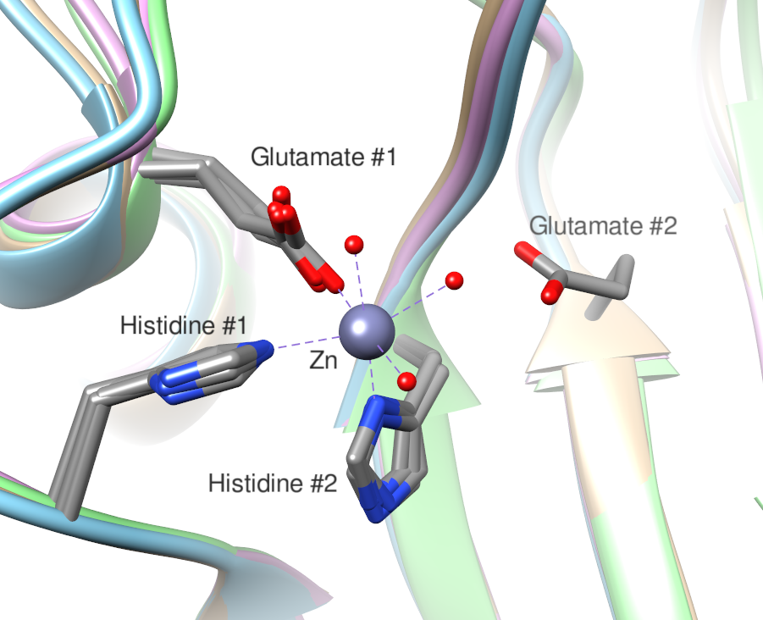 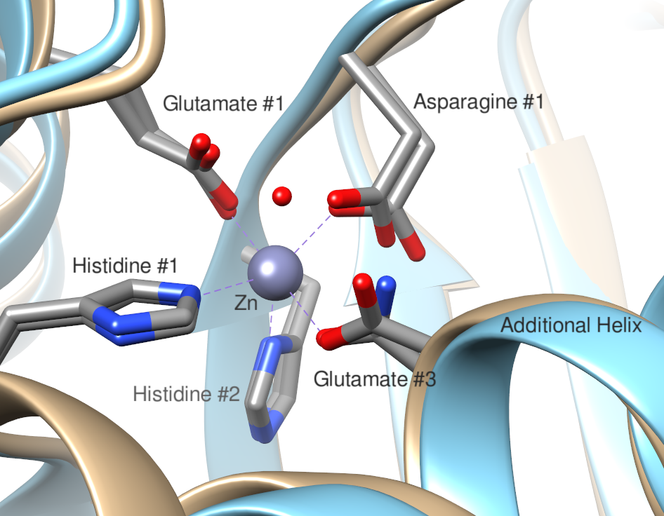

Two structures were shown to have this additional helix, in *B. henselae* and in *E. coli*. Rocaboy et al. showed the crystal structure of AmiC in *E. coli*, and provided evidence of the additional helix inhibiting activity, where AmiC lacking the helix resembled wild-type active NAMLAA16. Yang et al. published the structure of an AmiB homologue, showing a separation between structures containing the helix and structures lacking it (in bacteriophages and *B. subtilis*)20. Based on presence/absence of the helix, this paper posed three functions for NAMLAA: an endolytic bacteriophage function, an autolytic function in sporulating bacteria, and a cell wall lytic function in gram-negative bacteria.

## 1.3 Other pathways with NAMLAA involvement

As NAMLAA are present in gram-positive bacteria as well as gram-negative, alternative functions to the gram-negative cell wall lytic have been proposed.

In *C. difficile*, NAMLAA role has been proposed to be in degradation of the peptidoglycan cortex to allow spore germination. For the CwlD amidase in particular, the structure lacks an auto-inhibitory helix, but exhibits alternative inhibitory effects through GerS and Zn2+ binding, possibly forming the same interactions between Zn2+ and GerS as seen between Zn2+ and the auto-inhibitory helix19. As such, it may be proposed that NAMLAA lacking the auto-inhibitory helix may have involvement in sporulation pathways.

An endolytic, or antibacterial, role has also been proposed for NAMLAA. In bacteriophages, NAMLAA have been produced theorised to destroy specific bacterial cells – these NAMLAA align closely with NAMLAA in sporulating bacteria in that they lack the auto-inhibitory helix21. For such NAMLAA, an inhibitory ‘switch’ would not be necessary, as their role would be to destroy all peptidoglycan in the cell wall rather than carefully controlled selective breakdown of the septal ring.

Studies have shown that AmiA and AmiC have involvement in the Tat exporter pathway, and AmiB in the Sec exporter pathway, with a possible antimicrobial effect or a potential use in export of recombinant protein products from *E. coli*10.The role of NAMLAA has also been described in humans, with an antibacterial role in the blood by destroying the cell wall of pathogenic bacteria22, further linking NAMLAA to antimicrobial activity.

## 1.4 Project hypothesis and objectives

The literature implies that NAMLAA may have different functions depending on the bacteria it is found in, and while existing domain annotation tools fail to distinguish between these alternative functions, identification of evolutionary insertion/deletion regions within the highly conserved sequences and structures of NAMLAA may distinguish between species and could act as functional indicators in different bacteria.

The aims of this research are to:

* Define a candidate list of NAMLAA experimental and synthetic structures
* Explore the structural differences between NAMLAA across bacterial species
* Create and validate a multiple sequence alignment of NAMLAA
* Identify insertion/deletion regions possibly linked to bacterial evolution and use these to create a phylogenetic tree based on NAMLAA
* Identify phylogenetic groups which contain or lack the auto-inhibitory helix, and other insertion/deletions which might be indicators of NAMLAA function.

# 2 Materials and Methods

Additional scripts and all data used for all analysis can be found at the following GitHub repository: <https://github.com/sroseallen/Evolutionary-divergence-and-functional-investigation-of-NAMLAA-amidases>.

## 2.1 Experimental Structural Analysis

### 2.1.1 Identification of candidate AmiC structures

The FASTA sequence for 4BIN was downloaded from the Protein Data Bank (PDB)1,16,23. This sequence was used in the following database searches on 17/05/2023: a BLASTp search restricted to the PDB, a PDB search using the search term ‘Amidase 3’, a SCOP search using identifiers 4001130 (N-acetylmuramoyl-L-alanine amidase-like family) and 8092183 (AmiC domain)24–26. Two further searches were performed on 19/05/2023 in Pfam (identifier PF01520) and Interpro (search term Amidase 3), however these did not identify any new experimental structures27,28. A final search for structures was performed in the PDB using the GO annotation ‘N-acetylmuramoyl-L-alanine activity’ and search terms ‘AmiA’, ‘AmiB’ and ‘AmiC’ in May 202329,30. The full longlist of experimental structures identified from these searches is listed in Appendix B. Protein structures were shortlisted if they had a) a Pfam annotation of ‘Amidase 3’, b) a GO functional annotation of ‘N-acetylmuramoyl-L-alanine activity’, and c) an Interpro annotation of ‘Amidase 3 domain’.

### 2.1.2 Candidate structural alignments

To visualise the alignment of the shortlisted structures, the MatchMaker tool within UCSF Chimera was run with the following parameters: secondary structure predictions not re-calculated, pairwise alignment, reference structure 4BIN in *E. coli*, Needleman-Waltsch alignment31,32. Cropping of structures to the boundaries of the ‘Amidase 3’ domain based on the domain Pfam boundaries was carried out in UCSF Chimera using a command script (chimera_code_Amidase 3_structures.txt).

A multiple structural alignment for shortlisted structures was run using the Protein structure comparison service PDBeFold at European Bioinformatics Institute (<http://www.ebi.ac.uk/msd-srv/ssm>)33,34 (parameters: against the entire PDB archive, lowest acceptable match of secondary structure alignment=50%, Q-score >0.3, match individual chains and connectivity, unique and best matches only, Normal precision). Structures were removed from the shortlist if alignment was to another chain in a model already on the list, or if P-score was >3. Confirmatory alignment of all structures to all other structures in the shortlist was carried out using a local download of US-align35:

./USalign -dir chains_amidase_domain_only/ chain_list.txt -mm 4 -o sup -full T > output.txt

Comparison of RMSD scores between Amidase 3 structures and ‘AmiA-like’ structures were calculated using a one-way ANOVA test and following R code:

df <- data.frame(structure_type=c(rep("Amidase 3",19), rep("AmiA-like",5)), RMSD=c(1.1019, 1.3471, 2.2253, 1.1724, 1.4097, 1.1283, 1.0965, 1.0891, 1.0517, 1.0529, 1.2284, 1.0970, 1.2498, 1.0451, 1.0681, 1.0429, 1.4485, 1.1393, 1.4056, 3.9191, 4.0545, 3.8910, 4.0163, 4.0122))

oneway.test(RMSD~structure_type, df, var.equal=TRUE)

## 2.2 Sequence Analysis

### 2.2.1 Generating an AmiC sequence homologue list

BLASTp using FASTA protein sequences for each shortlisted experimental structure was performed through the BLAST web browser on May 2023, and repeated in April 2024. Sequences were first cropped to the Pfam annotation for the Amidase 3 domain. The blastp algorithm was run using the default parameters with the following specifications: Database restricted to 59,610,710 sequences in RefSeq Select36, no organism or model exclusion, word size 0.05 (95% significance), word size 5, no restricting on maximum matches in the query range, BLOSUM62 matrix, gap costs existence 11, extension 1. The top 5000 aligned sequence results were downloaded for each search for a total of 61,489 sequences. A Python script using BioPython 1.8337 was used to combine the sequences from BLASTp into a single list and remove duplicate entries (unique_blast_seqs.py). Input sequences for structures 1XOV, 3CZX, 3QAY, and 7TJ4 were not present within RefSeq Select, and were manually added to the final sequence list. The final number of sequences from BLASTp searches was 18,247.

The HMMER 3 phmmer (REST) web client38 was used to search for further sequences using the below command, although outputs were not deemed informative as alignments were provided without sequence ID/UniProt accession or the FASTA sequence.

python hmmer3_phmmer.py --email 'sallen10@student.bbk.ac.uk' --database 'uniprotrefprot'

InterPro was also searched using the search term ‘N-acetylmuramoyl-L-alanine amidase’. This identified 1 superfamily: [IPR036505](https://www.ebi.ac.uk/interpro/entry/InterPro/IPR036505/) (PGRP domain superfamily, associated with type-2 bacterial amidases), 6 families: [IPR010846](https://www.ebi.ac.uk/interpro/entry/InterPro/IPR010846/) (AmiA-like), [IPR014234](https://www.ebi.ac.uk/interpro/entry/InterPro/IPR014234/) (CwlD), [IPR017293](https://www.ebi.ac.uk/interpro/entry/InterPro/IPR017293/) (SH3-domain containing protein), [IPR049745](https://www.ebi.ac.uk/interpro/entry/InterPro/IPR049745/) (AmiC NAMLAA), [IPR050695](https://www.ebi.ac.uk/interpro/entry/InterPro/IPR050695/) (Amidase 3), and [IPR051206](https://www.ebi.ac.uk/interpro/entry/InterPro/IPR051206/) (amidase_2), and 4 domains: [IPR002502](https://www.ebi.ac.uk/interpro/entry/InterPro/IPR002502/) (amidase_2 domain), [IPR002508](https://www.ebi.ac.uk/interpro/entry/InterPro/IPR002508/) (Amidase 3 domain), [IPR021976](https://www.ebi.ac.uk/interpro/entry/InterPro/IPR021976/) (CBD_PlyG cell wall binding domain), and [IPR048586](https://www.ebi.ac.uk/interpro/entry/InterPro/IPR048586/) (Cwp6 domain). Homologous sequences listed under IPR002508 were added to the AmiC sequence list, since this was the only catalytic domain not associated with other protein families like amidase_2. A Python script adapted from the InterPro website (<https://www.ebi.ac.uk/interpro/result/download/#/protein/UniProt/entry/InterPro/IPR002508/|fasta>) was used to download all IPR002508 sequences (cropped to the Amidase 3 domain as annotated by InterPro), UniProt accession IDs, taxonomic IDs and species names (interpro_download_seqs.py).

### 2.2.2 Sequence annotation and filtering

Sequences from InterPro and BLASTp were combined into one list and duplicate sequences removed with two Python scripts which used BioPython 1.8337 (blast_interpro_collate_annotate.py; unique_blast_seqs.py). These scripts used taxonomic ID to identify unique sequences from the same species. All sequences from RefSeq were retained even where taxonomic ID was annotated at a higher order to avoid excluding novel species that were annotated at genus or family level (for example, *Paenibacillus* genus). RefSeq reference sequences were preferentially retained over InterPro sequences where multiple sequences from the same species were available. This was to apply caution to InterPro sequences sourced from WGS preliminary or unreviewed sequences as opposed to the non-redundant RefSeq sequences which were annotated and curated by NCBI staff. Taxnomic ID was extracted for each sequence within the InterPro API, and a separate Python script annotated BLASTp sequences with the taxonomic ID using a call to the NCBI REST API v239,40 (ncbi_taxid_call.py). If this call failed, sequences were manually searched within the NCBI Taxonomy database41, as for some species (such as the *Halomonas* genus) the species name did not match the stored name, but could be identified through manual searching.

All sequences were then annotated further with phylum and family. This was done using a Python script which made an API call to Taxallnomy42 (call_taxallnomy.py). A Python script then identified and removed sequences with non-specific family names (such as ‘Fam_of_environmental samples’ or ‘uncultured’), sequences which failed the Taxallnomy API call, and any sequence which was partial (defined as a sequence length < 131, a length more than 3 standard deviations (18.84) from the sample mean (187.63) of Amidase 3 domains in the sequence list) (pre_alignment_filtering.py).

### 2.2.3 Multiple Sequence Alignment, validation, and analysis

The initial multiple sequence alignment was performed using a local download of kalign-343, which was able to compute a full alignment within reasonable computational time due to its 256 kmer clustering algorithm and reduced amino acid similarity alphabet. The below command produced the initial alignment:

D:\msys2\usr\bin\kalign.exe -i keep_seq_taxid.txt -o D:\Documents\MSc_Project\MSc_Project\01_DATA\Amidase 3\04_Multiple_Alignment\alignment_1.fa

The output was then filtered using OD-seq44, which is designed to detect outliers in large multiple sequence alignments by calculating an average distance matrix and predicting outliers using bootstrapping (1000 pseudo-replicates) to compute the mean and standard deviation of distance measures between an inspected sequence and the overall alignment. The following command was used to run a local instalment of OD-seq:

OD-seq -i alignment_1.fa -r alignment_1_odseq.txt -o alignment_1_outliers.txt -c alignment_1_nonoutliers.txt -m affine -s 1

where ‘-r’ is the file name for all results, ‘-o’ is the file name for outlier sequences, ‘-c’ is the file name for non-outlier sequences, ‘-m’ is the gap penalty assignment method, and ‘-s’ is the number of standard deviations from the average distance permitted for sequence retainment. The Affine method gave a higher gap opening penalty (3 points) than linear, and 1 point for each extension of an existing gap, meaning short gaps would be penalised in otherwise conserved regions without strongly penalising long insertion regions as would be done for the Cumulative method. Alignment with kalign-3 was repeated as above. An R script using the Biostrings package45 was used to further filter sequences which introduced a gap containing information from <1% of all sequences in the alignment (gram_stain_updater.R). A 0.1% information threshold was also attempted, however a shorter alignment with a stricter threshold for information content would be more likely to contain related sequences. The MSA was visualised within Jalview46.

Validation was carried out according to Modi and Dunbrack Jr.47 by comparing aligned residues in the structural alignment with the sequence alignment. In short, a Python script using Matplotlib v3.8.448, pandas v2.2.049, seaborn v0.13.250 and BioPython 1.8337 compared aligned residues in the US-align structural alignment of each protein pair to the sequence alignment of the same proteins, and calculated the Positive Predictive Value (PPV): the ratio of sequence pairs aligned in both the sequences and structures to the total number of residues aligned in the sequences, and True Positive Rate (TPR): the ratio of sequence pairs aligned in both the sequences and structures to the total number of residues aligned in the structures (post_alignment_validation.py).

### 2.2.4 Conservation of regions in the final MSA

A conserved region was defined a continuous section of at least 3 columns where a) average occupancy of the columns was >90%, b) there was not >1 continuous column of <90% occupancy (gap-rich columns), and c) the region was not composed of >50% gap-rich columns. Regions were identified using JalView conservation quality scores, and boundaries determined using the above rules by viewing the alignment within JalView46,51,52. Logos were generated for conserved regions using WebLogo53, coloured by charge (positive=green, negative=red) and polarity (polar=blue, non-polar=black). Conservation scores were generated for each column using Jalview web services51,52, and mapped onto 4BIN and 3NE8 using custom UCSF Chimera attribute assignment files and rendering by attribute.

During information filtering of the post-aligned sequences, sequences were annotated using an R script as being gram-positive or gram-negative based on the species phyla per the algorithm for the R package AMR54, where bacteria within the phyla *Actinobacteria (*or *Actinomycetota), Chloroflexi, Firmicutes* (or *Bacillota*)or *Tenericutes* are gram-positive, and all else are gram-negative (gram_stain_updater.R). To quantify the level of conservation, species were annotated using a Python script depending on % of occupied columns (i.e. non-gap positions) across the predicted mobile helix I-6 region, and the annotated gram-status and phylum examined across species to identify patterns in conservation (mobile_helix_conservation.py).

## 2.3 Sequence clustering and phylogeny

### 2.3.1 Feature identification and Sequence Clustering

For each insertion region, a Python script (mobile_helix_conservation.py) assigned each sequence a value of “0” if the sequence occupied a lower-than-average (mean average) number of positions in the region with information, and a value of “1” if the sequence occupied a higher-than-average number of positions. This gave each sequence an 8-digit binary fingerprint for the 8 insertion regions. These fingerprints were used to cluster sequences using the Scikit-learn Python library to perform PCA with 8-components and 3-components55 (pca_region_variation.py).

### 2.3.2 Phylogeny

10 sequences from each binary fingerprint cluster were selected using the ‘random’ Python package. Where a fingerprint had <10 sequences, all sequences were selected. A representative phylogenetic tree for these species was generated using the FastME webserver56. The FastME parameters used were: Protein alignment, LG substitution model, Gamma distributed rates across sites, Gamma shape parameter 1, BioNJ algorithm57, Tree refinement with SPR_BalME, and 100 bootstraps. The resulting phylogenetic tree was visualised using the Interactive Tree of Life (iTOL)58 and sequences coloured according to their binary fingerprint.

## 2.4 Synthetic Structural Analysis

ColabFold59 was not used for most of the synthetic structure predictions despite the accessibility of options such as a custom multiple sequence alignment. This was because the required custom alignment format requires sequences to be aligned in reference to the query sequence, and the alignment generated for this research is all-vs-all for the 20,403 (therefore the final alignment is longer than most query sequences, and is not compatible with the ColabFold notebook).

5 NCBI accessions from each of the top 10 fingerprints were selected and a structural prediction was generated using either the ColabFold python notebook59 to generate graphs for average pLDDT and multiple sequence alignment coverage, or the AlphaFold3 webserver60, which was used to predict the majority of structures. The following parameters were used for the sequence predicted with ColabFold: weight_set=OpenFold, model_mode=multimer, relax_prediction=True(default).

For structural predictions, the full protein sequence was downloaded using a Python script from NCBI RefSeq or UniProt respectively using the sequence accession number in the file ‘BLAST_Interpro_all_seq.txt’ as a search parameter (domain_structure_prep.py).

mmCIF structures were examined and modelled using UCSF Chimera31 and coloured by pLDDT score using Render by Attribute (“bfactor”). Low confidence flags are defined as a pLDDT score for a region of <70. Fingerprint clustering was repeated for insertion regions which had been examined using predicted structures and appeared to be impactful (mobile_helix_conservation_validated_ins.py)

# 3 Results

## 3.1 Experimental Structural Analysis

### 3.1.1 Generating a candidate AmiC structure shortlist

From an initial structural longlist constructed of possible NAMLAA structures across species, a final shortlist of 19 candidate AmiC structures was curated, which matched on Pfam annotation, GO annotation, and an Interpro domain annotation of Amidase 3 (Table 1). Searching of protein structure databases (see Methods) identified 24 potential NAMLAA structures, however five of these were annotated by Pfam27 as having an ‘AmiA-like’ domain rather than an ‘Amidase 3’ domain, and so were removed from the candidate shortlist.

The lengths of the sequences for these structures varied in length from 175-638, however length of the annotated Amidase 3 domain varied less significantly, with a range from 159-215. The species in this shortlist also vary greatly, consisting of a mixture of gram-positive and gram-negative bacteria as well as bacteriophages, but tend to be reported as having a zinc ion ligand. PDB structures 5J72 and 4RN7 are both from *Clostridium difficile*, however were deposited by different research groups and present different structures and sequences, where 5J72 is much longer. It is possible 4RN7 is a ‘cropped’ structure representing just the catalytic domain of this protein. Two of these structures (4M6H and 4M6I) are the same protein sequence from the same bacterium, however both were retained as one structure reflects the metal-bound form of the amidase, which may affect protein structure and therefore is relevant in subsequent structural analyses.

**Table 1: Shortlist of 19 candidate experimental structures of NAMLAA AmiC homologues across different bacterial species.** Ligand, organism and sequence information taken from the PDB entry for each structure. Chain listed is the best-matched chain identified by the respective identification method for this shortlist. PDB entry reference is listed for each structure, as well as the publication where available.

|  |  |  |  |  |  |  |  |  |
| --- | --- | --- | --- | --- | --- | --- | --- | --- |
| PDB ID | Year in PDB | PDB  chain | Organism | Ligand | Full Sequence Length | Amidase domain length | Identification Method | Sequences identified from BLASTp |
| 4BIN23*,*16 | 2013 | A | *Escherichia coli* | Zn2+ ,Na+ | 403 | 215 | PDB search ‘AmiC’ | 5000 |
| 7B3N61,62 | 2020 | A | Prophage from *Thermus parvatiensis* | Zn2+, Na+, Cl-, Glycerol, SO42-, Ethanesulfonic Acid | 177 | 159 | BLASTp search, 4BIN reference sequence | 5000 |
| 3CZX63 | 2008 | A | *Neisseria meningitidis* | Zn2+ | 182 | 169 | PDB search ‘Amidase 3’ | 185 |
| 5J7264,65 | 2016 | A | *Clostridium difficile* | Citric Acid, Zn2+, Ca2+, Cl-, Na+ | 638 | 181 | BLASTp search, 4BIN reference sequence | 5000 |
| 7TJ466,67 | 2022 | B | *Staphylococcus aureus* | Zn2+ | 176 | 165 | BLASTp search, 4BIN reference sequence | 5000 |
| 4RN768 | 2014 | A | *Clostridium difficile* | Zn2+, Formic Acid, Glycerol, Ethanesulfonic Acid | 188 | 174 | BLASTp search, 4BIN reference sequence | 5000 |
| 5EMI69,13 | 2015 | A | *Nostoc punctiforme* | MES, MRD, Zn2+ | 180 | 169 | BLASTp search, 4BIN reference sequence | 5000 |
| 3NE870,20 | 2010 | A | *Bartonella henselae* | ACETATE ION, FORMIC ACID, GLYCEROL, Zn2+ | 234 | 215 | BLASTp search, 4BIN reference sequence | 5000 |
| 4M6G71,72 | 2013 | A | *Mycobacterium tuberculosis* | Zn2+ | 225 | 203 | PDB search ‘Amidase 3’ | 2114 |
| 1JWQ73 | 2001 | A | *Paenibacillus polymyxa* | Zn2+ | 179 | 170 | BLASTp search, 4BIN reference sequence | 5000 |
| 4LQ674,14 | 2013 | A | *Mycobacterium tuberculosis* | SO4-, Zn2+, Cl-, Pt2+ | 218 | 203 | PDB search ‘Amidase 3’ | 2114 |
| 4M6H75,72 | 2013 | A | *Mycobacterium tuberculosis* | None reported | 225 | 203 | PDB search ‘N-acetylmuramoyl-L-alanine activity’ | 2114 |
| 4M6I76,72 | 2013 | A | *Mycobacterium tuberculosis* | Zn2+ | 225 | 203 | PDB search ‘Amidase 3’ | 2114 |
| 7AGO77,78 | 2020 | A | *Mycobacterium* | Zn2+, D-alpha-glutamine, Alanine | 233 | 203 | PDB search ‘Amidase 3’ | 1942 |
| 7AGM79,78 | 2020 | A | *Mycolicibacterium smegmatis* | Zn2+ | 230 | 203 | PDB search ‘Amidase 3’ | 2435 |
| 7AGL80,78 | 2020 | A | *Mycobacterium* | Zn2+ | 233 | 203 | PDB search ‘Amidase 3’ | 1942 |
| 7RAG81,19 | 2021 | B | *Clostridium difficile* | Zn2+, 1,2-Ethanediol | 210 | 188 | PDB search ‘Amidase 3’ | 5000 |
| 1XOV82,21 | 2004 | A | *Listeria monocytogenes* | Cl- ,GLUTAMIC ACID, LYSINE, 2-AMINO-2-HYDROXYMETHYL-PROPANE-1,3-DIOL, SO4-, Zn2+ | 326 | 167 | PDB search ‘Amidase 3’ | 1066 |
| 3QAY83,84 | 2011 | A | *Colneyvirus* | SO4-, Zn2+ | 180 | 172 | PDB search ‘Amidase 3’ | 463 |

### 3.1.2 Candidate structural alignment

Of the remaining 19 candidates, structural variation in the N-terminal domain of all proteins was shown, with specifically 5J72 (*C. difficile*) having a large, unique CW-2 binding domain64,65. When cropping each protein to the C-terminal Amidase 3 domain only, the secondary structures within the domain were conserved, with the exception of an additional α-helix present for some structures (Figure 2).

**Figure 2: Chimera visualisation of alignment of the 19 shortlisted structures.** A: Original structures as presented in the Protein Data Bank including N-terminal domains. B: Structures cropped to the Amidase 3 domain boundaries.Helices are coloured in red, and beta sheets in purple. The additional α-helix is coloured in green, and is present for the following PDB structures: 4BIN, 3NE8.

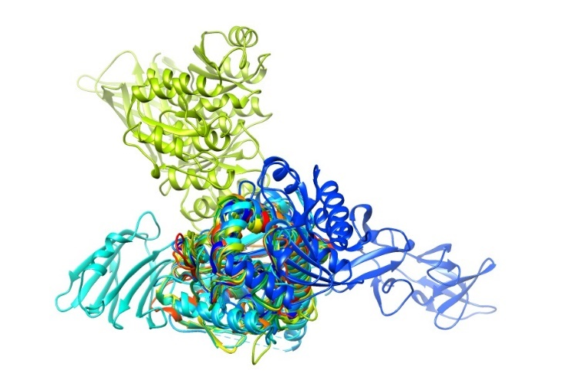 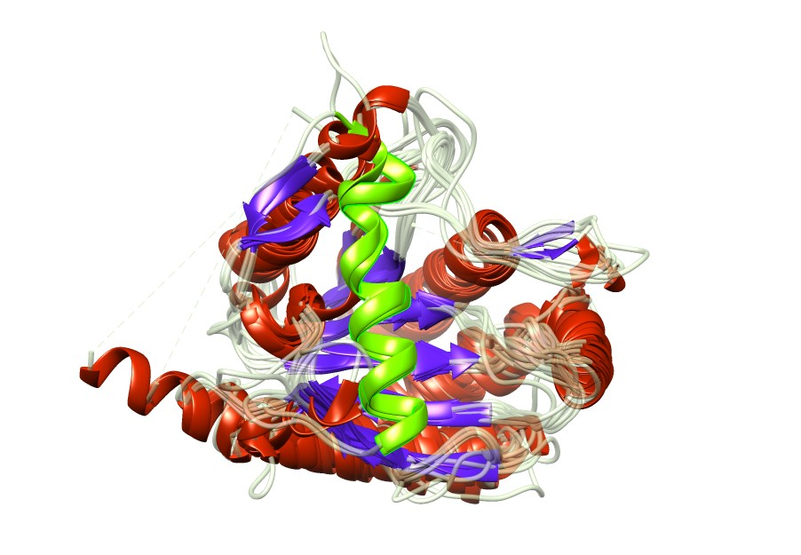

**B**

**A**

The 19 cropped candidate structures were then aligned for more detailed examination in PDBeFOLD. As the visualisation showed high variability outside of the Amidase 3 domain, these structures were cropped to this domain only before alignment. Overall, the RMSD demonstrated a close alignment of the carbon alpha backbone across the 19 structures (RMSD = 1.655), and a low Q-score (0.3561), which reflects large insertions in the alignment (Figure 3). This is an improvement from the structural alignment performed with the uncropped structures (RMSD = 1.5525, Q-score 0.1255)(Appendix C). Notably, the additional helix structure present in 4Bin and 3NE8 was absent from another gram-negative structure, 3CZX. Several bacteria also have a sequence consisting of a short helix and two beta strands near the start of the alignment.

**Figure 3: Multiple structural alignment representation of the 19 structures in PDBeFOLD.** Secondary structure predictions have been coloured; Helices = Red, Beta Sheets = Purple. The additional helix in 3NE8 and 4BIN has been highlighted in green.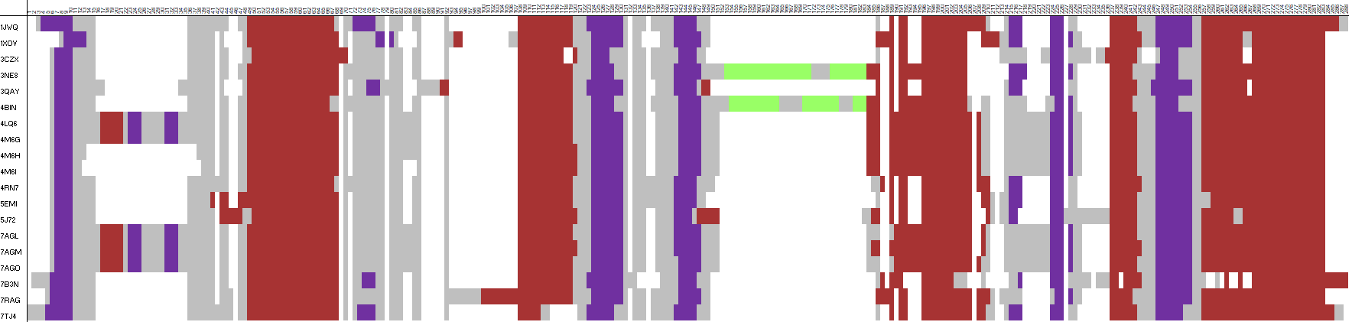

Confirmatory alignment with US-align produced an average TM-score of 0.83417 for the 19 cropped structures, with all structures having an individual TM-score above 0.8 with the exception of structures from gram-negative bacteria; 4BIN, 3NE8, and 3CZX (Table 2). This is an improvement over the uncropped structures, which had an average TM-score of 0.58520 (Appendix C). To validate removal of the ‘AmiA-like’ structures from the candidate list, a further structural alignment of the 19 candidates plus the five AmiA-like structures was performed; a one-way ANOVA for difference in means between the RMSD for the two groups indicated that the AmiA-like group is significantly different to the candidate 19 structures (p-value: 2.26x10-16) (Appendix C).

**Table 2: PDBeFOLD and USalign scores from multiple alignment of the 19 cropped structures.**

|  |  |  |  |
| --- | --- | --- | --- |
| PDB Structure | PDBeFOLD RMSD | PDBeFOLD Q-score | USalign TM-score |
| 1JWQ | 0.9662 | 0.6479 | 0.88316 |
| 1XOV | 1.5857 | 0.5955 | 0.82427 |
| 3CZX | 1.7016 | 0.5697 | 0.79843 |
| 3NE8 | 1.1502 | 0.5314 | 0.74304 |
| 3QAY | 1.8619 | 0.5341 | 0.81289 |
| 4BIN | 0.9537 | 0.5699 | 0.77128 |
| 4LQ6 | 0.7409 | 0.5914 | 0.81818 |
| 4M6G | 0.7719 | 0.5885 | 0.81727 |
| 4M6H | 0.7498 | 0.6693 | 0.87099 |
| 4M6I | 0.7515 | 0.6882 | 0.88625 |
| 4RN7 | 0.7880 | 0.6842 | 0.88708 |
| 5EMI | 0.9011 | 0.6906 | 0.88620 |
| 5J72 | 1.2414 | 0.6005 | 0.83297 |
| 7AGL | 0.7904 | 0.5867 | 0.81593 |
| 7AGM | 0.7998 | 0.5858 | 0.81706 |
| 7AGO | 0.7946 | 0.5863 | 0.81590 |
| 7B3N | 1.7498 | 0.5651 | 0.85630 |
| 7RAG | 1.0864 | 0.5987 | 0.81271 |
| 7TJ4 | 1.1036 | 0.6442 | 0.88514 |

## 3.2 Sequence Analysis

### 3.2.1 Generating an AmiC sequence homologue list

BLASTp searches for the top 5000 RefSeq sequences significantly aligned to each of the candidate structure Amidase 3 domains gathered a total of 18,247 unique candidate sequences. From InterPro, download of sequences annotated as IPR002508 identified a further 70,617 sequences, and after combining these with the sequences identified from BLASTp and removing duplicates present in both databases, the final unique number of sequences was 36,233.

### 3.2.2 Multiple Sequence Alignment and Validation

To identify conserved and insertion regions across species and cluster these accordingly, a multiple sequence alignment (MSA) for the sequence list was generated. To ensure a broad coverage of all possible AmiC homologues, sequence identification may have included non-NAMLAA proteins with a similar catalytic domain. To adjust for these less similar protein sequences pre-alignment, partial sequences (n=666) and sequences with a missing or unclassified taxonomic lineage (n=3,326) were also removed before alignment. After filtering, 32,241 sequences remained for the initial MSA.

The initial MSA was further filtered in two stages:

* Outlier detection program OD-seq44 removed distant sequences (n=3,268), no sequences from candidate structures were removed.
* A separate R script removed sequences that introduced gaps which represented information from <1% of the data (see Methods). This removed 7 candidate sequences: 1JWQ (a *Paenibacillus* species), 3QAY (a bacteriophage), 3CZX (from *Neisseria meningitidis*), 7AGL and 7AGO (candidates from the *Mycobacteriaceae* family), 5J72 (*Clostridioides difficile*) and 7B3N (from the *Thermaceae* family, which is known to be distinct from other bacterial families through conserved signature insertions/deletions85).

The final post-filtered alignment comprised 20,304 sequences and was 399 residues long.

As described by Modi and Dunbrack Jr in 201947, the MSA was then validated by using a structural alignment of the candidate structures retained in the final alignment (see Methods). On average, TPR was 0.897 and PPV was 0.955 (TPR and PPV for each of the 9 structures are in Appendix D).

Using the alignment, regions of conservation and regions containing insertions in a minority of species were identified. There were 8 total insertion regions which are described in Table 3, the shortest being I-3 (5 residues) and the longest being I-6 (58 residues). To explore which regions these low-occupancy insertions refer to, conservation was mapped onto the 4BIN and 3NE8 structures (Figure 4), which showed high conservation in the enzymatic core and active site of the Amidase 3 structure and poor conservation of the outer helical structures. Region I-6, the longest insertion, maps onto both structures as the auto-inhibitory helix.

**Table 3: Descriptive summary of final multiple sequence alignment of 20,304 sequences, length 399 residues.** Conserved region IDs = ‘C-X’, Insertion region IDs = ‘I-X’. Logos for conserved regions created using WebLogo53. Full web logo for all regions can be found in Appendix E.

|  |  |  |  |  |  |
| --- | --- | --- | --- | --- | --- |
| Region | Region Columns | Region Length | Average Occupancy (%) | Consensus sequence | Logo |
| I-1 | 1-6 | 6 | 19.5% | -- | -- |
| C-1 | 7-14 | 8 | 97.3% | VVIDPGHG |  |
| I-2 | 15-57 | 43 | 30.1% | -- | -- |
| C-2 | 58-80 | 23 | 92.5% | TREKDVTLAIAKRLRALLEAQEP |  |
| I-3 | 81-85 | 5 | 26.1% | -- | -- |
| C-3 | 86-95 | 10 | 99.6% | ARVVLTRDGD |  |
| I-4 | 96-128 | 33 | 16.1% | -- | -- |
| C-4 | 129-153 | 25 | 95.5% | LRERVEIARKAGADLFVSIHADDAAF |  |
| I-5 | 154-175 | 22 | 27.9% | -- | -- |
| C-5 | 176-183 | 8 | 92.2% | GASVYALS |  |
| I-6 | 184-241 | 58 | 41.4% | -- | -- |
| C-6 | 242-251 | 10 | 85.2% | LADQVLLDEL |  |
| I-7 | 252-303 | 52 | 48.8% | -- | -- |
| C-7 | 304-354 | 51 | 92.9% | AGFAVLKEAPDKIPSVLVETGFISNPEEEALLTSPAYQQKLAEAIADGIKR |  |
| I-8 | 355-399 | 45 | 13.5% | -- | -- |

**Figure 4: BLOSUM62 conservation scores mapped onto 4BIN and 3NE8.** Visualisation of structures was carried out using UCSF Chimera.A: 4BIN, B: 3NE8. Pink colouration = highly conserved residue, blue colouration = poorly conserved residue. The proposed mobile helix has been annotated in each structure.

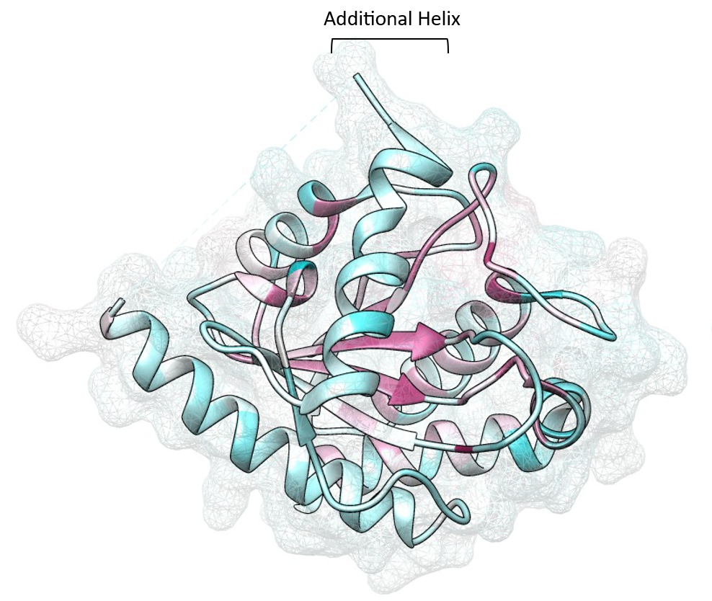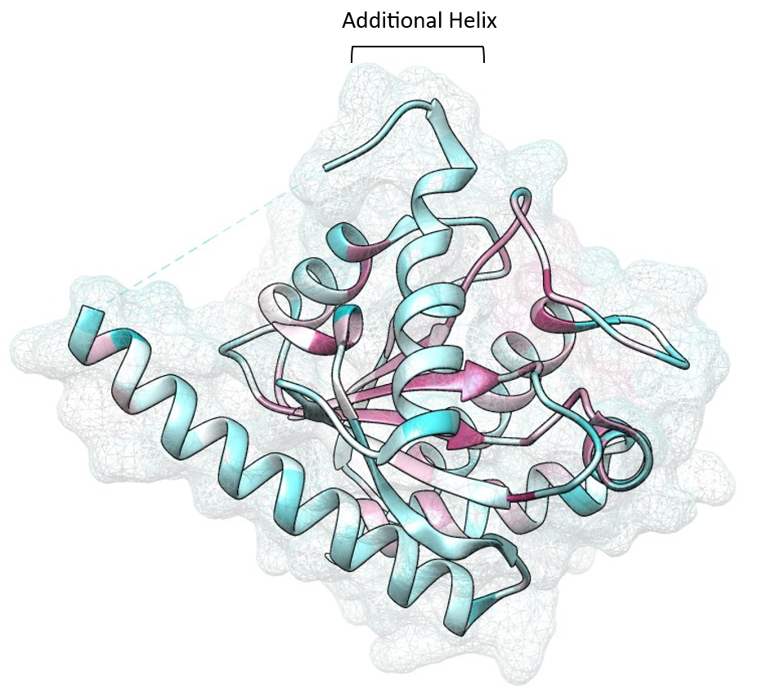

**A**

**B**

### 3.2.3 Conservation of mobile region across species

Having defined the boundaries for conserved and less-conserved regions, species in the alignment were then examined to explore any species clustering patterns based on relative conservation of I-6. Based on the hypothesis that the mobile helix is linked to differing function in gram-negative (cell wall division) and gram-positive (endolytic/sporulating behaviour) bacteria, species were also annotated with their predicted gram staining status (Figure 5).

**Figure 5: Raw count of per-species occupancy of the I-6 region (left) and I-7 region (right), annotated by gram staining status.** Occupancy of other insertions is presented in Appendix F.

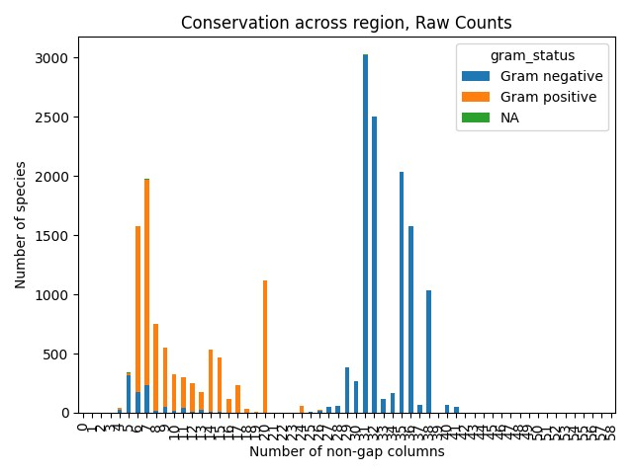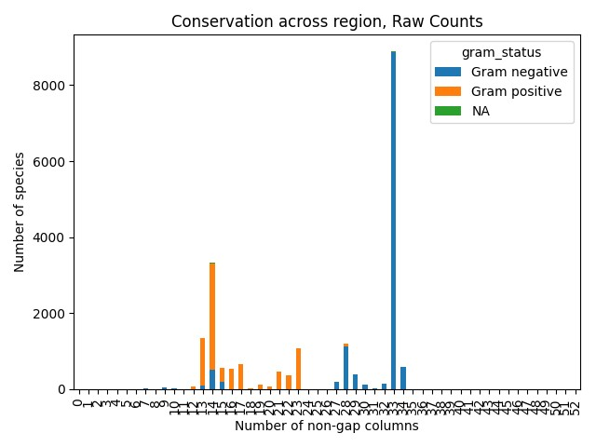

Looking at I-6, there is a clear difference between ‘large insertion’ (>25 amino acids) and ‘low/no insertion’ characterised by the predicted gram-staining status of the bacteria. Some gram-negative bacteria lack this insertion, aligning better with gram-positive bacteria with regard to this region. On further investigation, the majority of these bacteria share a common phylum (*Cyanobacteriota*). A considerable number of gram-positive bacteria occupied 20 columns in I-6, marking them as a unique group separate from both other gram-negative and gram-positive bacteria. With the exception of 12 species, these belonged to the *Streptomycetaceae* family. The same patterns were seen in the I-7 region, which for the 3NE8 and 4BIN structures maps onto an α-helix adjacent to I-6.

## 3.3 Sequence Clustering and Phylogeny

### 3.3.1 Feature identification and clustering

To quantify the degree of variation afforded by these insertion regions, 8-component PCA was conducted on the full dataset of sequences using the occupancy of each sequence in each insertion region. The scree plot (Figure 6B) shows that the first two PCs represent most of the total variance in the species, are most informative of the insertion regions, and therefore these two components were selected for the final PCA.

**Figure 6: PCA plots demonstrating variability for each insertion region.** A: Plot of PC1 and PC2, coloured by phylum. B: Scree plot for the 8-component PCA, the first two components represent most of the total variance seen in the insertion regions. C: Biplot of the 8 insertion regions projected onto PCA scatter plot of PC1 and PC2. D: PC1 and PC2 plot coloured by predicted gram staining status.

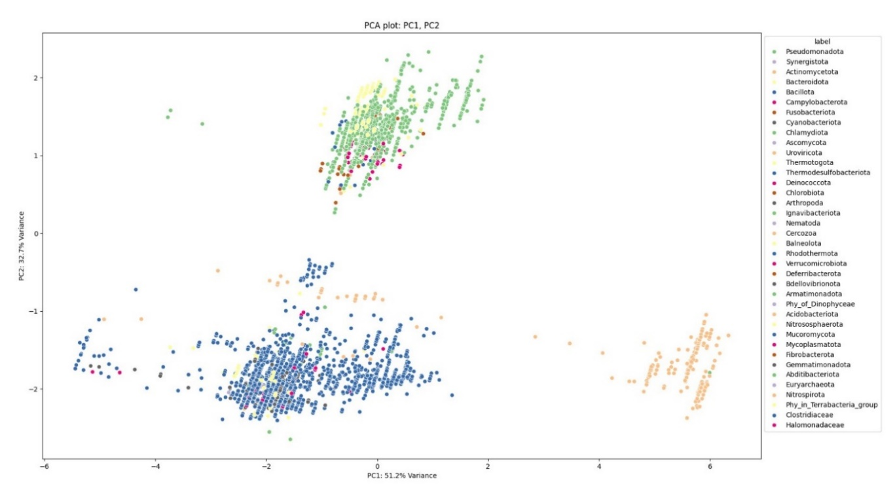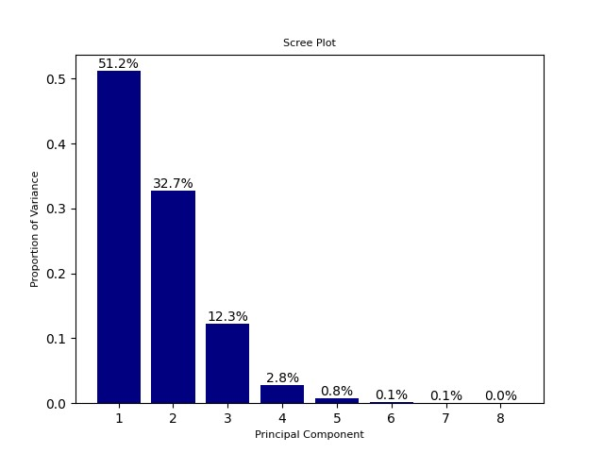 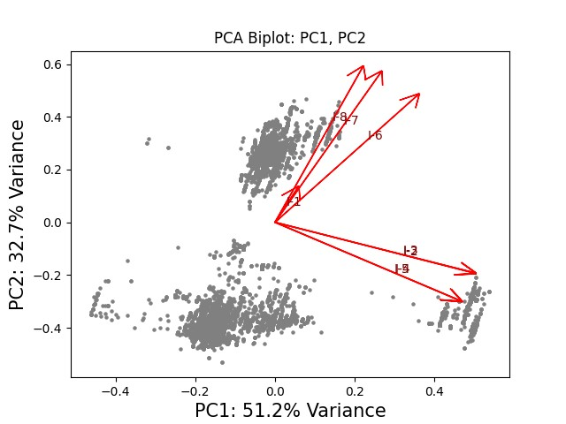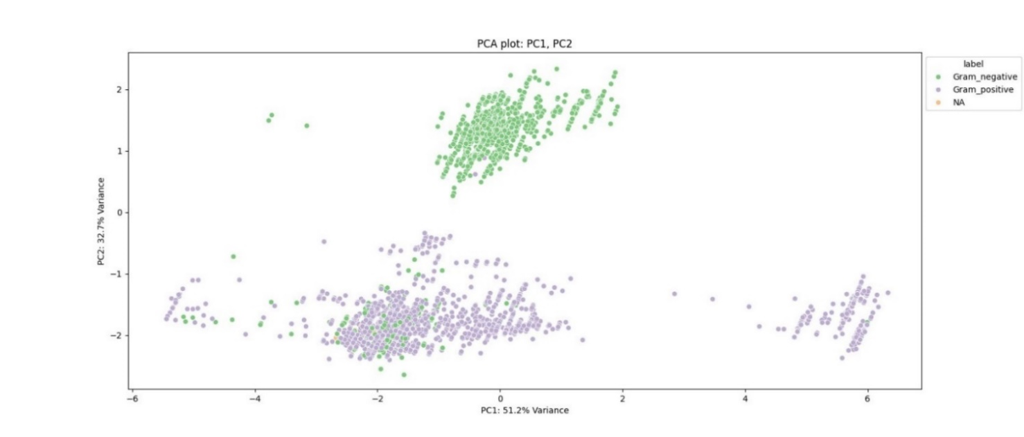

**D**

**B**

**C**

**A**

From the plot of PC1 and PC2 (Figure 6A), three major clusters emerge. Species with high variation in PC1 and low variation in PC2, which are largely *Actinomycetota*; species with mid-low variation in both PC1 and PC2, which are largely *Bacillota*; and species with high variation in PC2, which are largely *Pseudomonadota* and *Bacteroidota*. Using this clustering approach, separation between the gram negative phyla and the gram positive phyla is clear, with an additional separation of two major gram positive phyla. The biplot reveals which features inform PC1 and PC2 (Figure 6C); larger occupancy in I-6, I-7 and I-8 is indicative of the species clustering in a homogenous gram-negative group, while higher occupancy in I-2 and I-4 in particular indicates belonging to the *Actinomycetota* phylum. This is demonstrated by the loading values for each feature, which are highest for I-6, I-7 and I-8 for PC2 and highest for I-2, I-3, I-4 and I-5 for PC1 (Table 4). Occupancy in I-1 is not informative towards any cluster, with a short eigenvector and little to no clustering around the centre of the plot, and seems to be the only informative feature for PC3 based on the loading scores.

**Table 4: Loading scores for PC1, PC2 and PC3 for the 8 insertion region features.**

|  |  |  |  |
| --- | --- | --- | --- |
|  | PC1 | PC2 | PC3 |
| I-1 | 0.039796 | 0.091457 | 0.994439 |
| I-2 | 0.458354 | -0.17679 | 0.00627 |
| I-3 | 0.458183 | -0.17532 | 0.002198 |
| I-4 | 0.428548 | -0.2746 | 0.001025 |
| I-5 | 0.425983 | -0.27245 | -0.00017 |
| I-6 | 0.332375 | 0.448069 | -0.05178 |
| I-7 | 0.247136 | 0.529326 | -0.0395 |
| I-8 | 0.204286 | 0.546864 | -0.0825 |

### 3.3.2 Phylogeny

Using the regions identified in Table 3, each sequence was then assigned an initial 8-digit binary fingerprint based on if that sequence had a higher-than-average occupancy in each of the 8 insertion regions. In total, there were 62 unique fingerprints, and a representative phylogenetic tree was generated based on these fingerprints using randomly selected sequences from each fingerprint cluster (Appendix H). A summary of the occurrences of these fingerprints is in Figure 7, where it becomes clear the most common combinations of insertion regions contain I-5, I-6, I-7, and I-8.

**Figure 7: Summary boxplot of 62 binary fingerprint clusters present in the overall sequence dataset of 20,304 sequences.**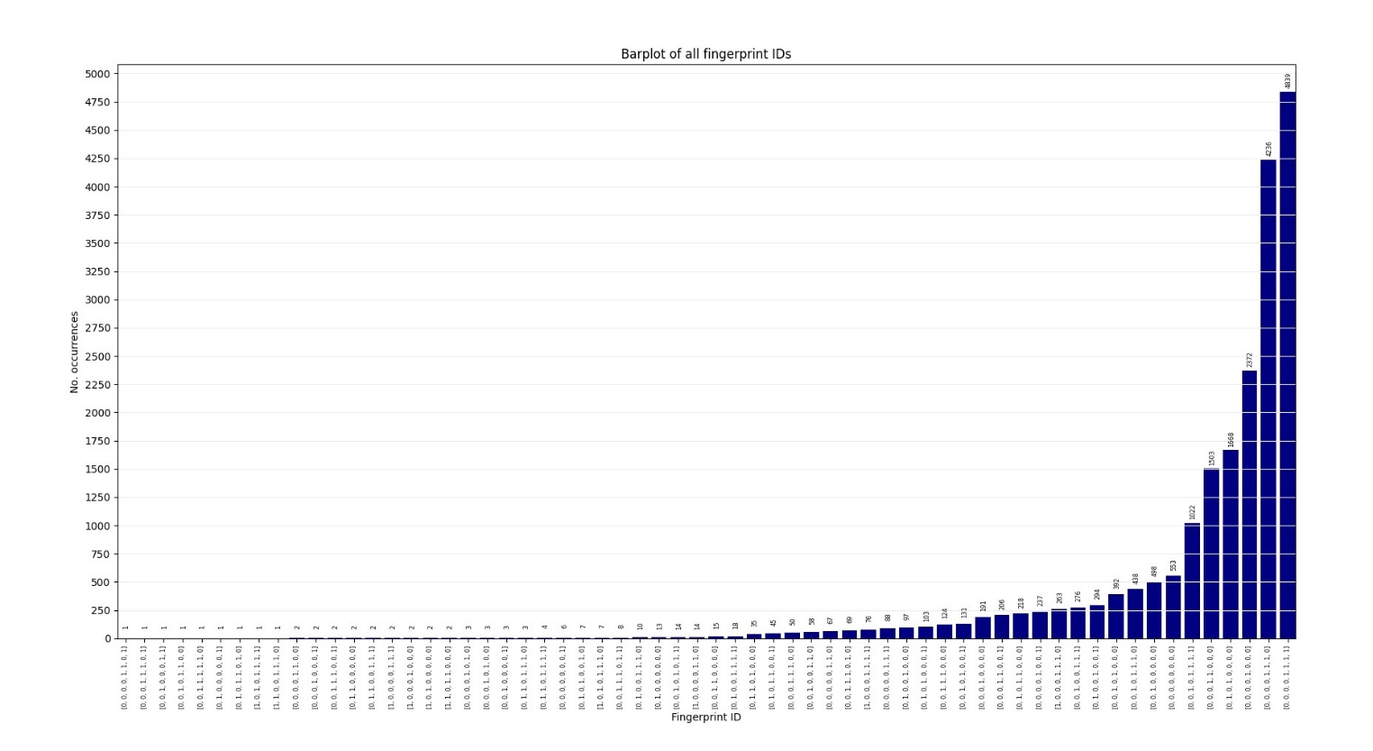

Looking at the representative phylogenetic tree, species with both these regions were predominately gram-negative phyla. Other associations were seen with specific phyla, such as the I-1 region and *Pseudomonadota*, and I-4 associated with gram-positive phyla.

## 3.4 Synthetic Structure Analysis

### 3.4.1 Structural Prediction

Due to the scarcity of NAMLAA experimental structures in the PDB, many sequence clusters were not represented by experimental structures. As such, synthetic predictions were required to examine probably structures.

4,776 of the sequences in the final sequence dataset had a corresponding structure within the AlphaFold2 Protein Structure Database86. For these predicted structures, the core Amidase 3 structure maintained generally high average pLDDT (>90), but outside of the core structure confidence was generally poor (pLDDT<50), especially with regard to position in physical space between multiple domains (Figure 8).

**Figure 8: Representative examples of structural predictions from the AlphaFold2 Protein Structural Database.** A: UniProt ID A0A239XZL5, Sphingobacterium mizutaii, cluster group 00000000. B: UniProt ID A0A1H8MXL3, Duganella sp., cluster group 00001111. C:UniProt IDA0A356EAJ1, Pasteurellaceae bacterium, cluster group 00001110. Larger structures appear to be multimeric, with loops of high uncertainty between possible domains and general disorder predicted. Structures coloured by pLDDT score; orange = <40, yellow = <50, light blue = <70, dark blue = <90

**C**

**B**

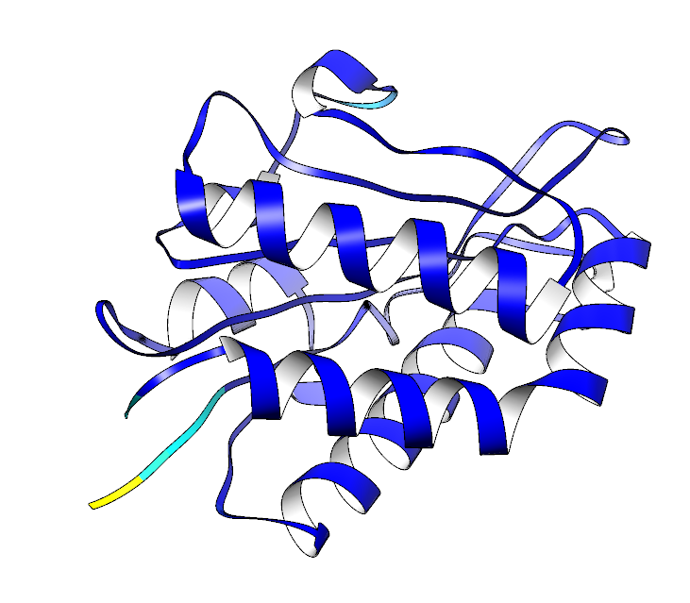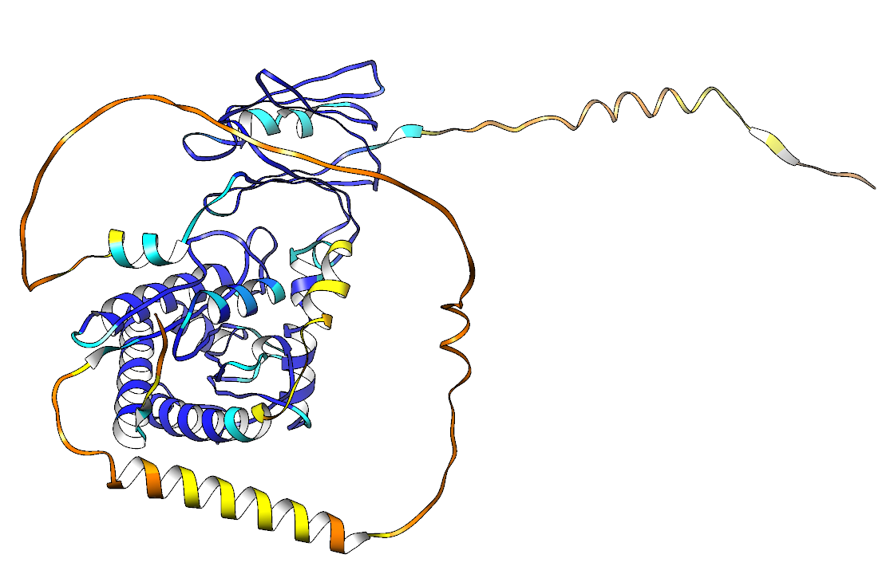 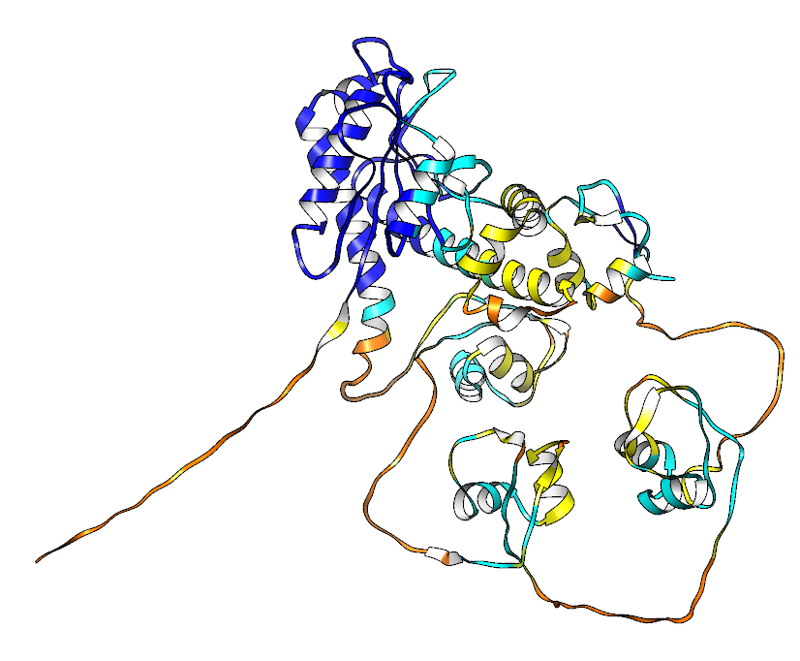

**A**

The poorer quality in multimeric proteins may be due to generation using a monomeric version of the AlphaFold2 model. As such, a random selection of sequence structures were predicted using updated models (such as multimeric AlphaFold2, and AlphaFold3). However, even with the updated model, sequence coverage for regions not covered by dedicated domains remained poor, with high-scoring pAE values for regions outside the core Amidase 3 domain (Figure 9). Low certainty in position of non-domain (potentially disordered) regions in relation to the core Amidase 3 enzyme means conclusions cannot be drawn from these inter-domain positions with confidence.

**Figure 9: ColabFold exemplar prediction of UniProt A0A8X6EUL1.** A: Sequence coverage output from the multiple sequence alignment search. B: Predicted pLDDT for each position for the top 5 performing structures. C: pAE plot for the top performing model. D: Visualisation of the top performing predicted structure, coloured by pLDDT. Structure coloured by pLDDT score; orange = <40, yellow = <50, light blue = <70, dark blue = <90

**B**

**A**

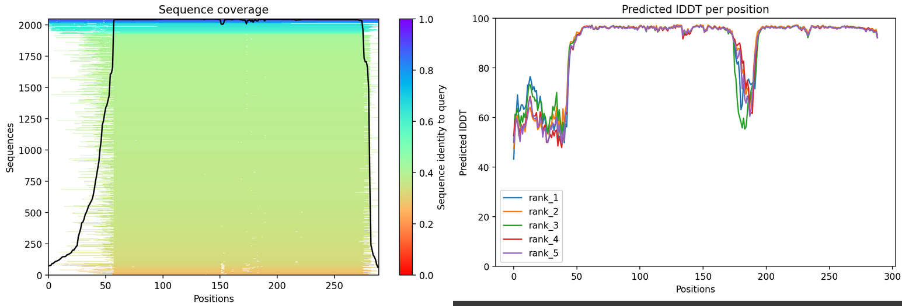

**D**

**C**

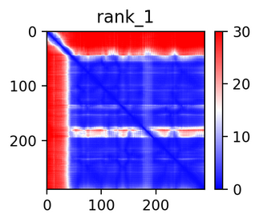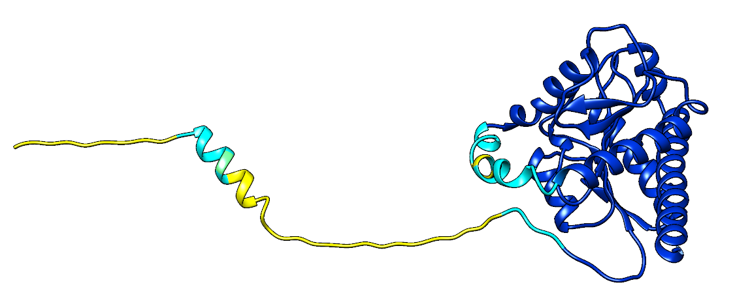

Although the positions of different domains were often predicted poorly, the core Amidase 3 domain (and often other domains in the protein) tended to be predicted well (with an average pDDT >90). As such, it is possible to isolate these domains between fingerprints and draw conclusions from the differences in predicted structure.

### 3.4.2 I-5, I-6, I-7, and I-8

The I-5 region, not associated in particular with a specific phylum and appearing fairly ubiquitous when looking at the representative phylogeny, maps to a loop region position at the ‘lip’ of the active site entrance. A loop is present in all the predicted structures, however the loop is extended in structures identified to have an I-5 insertion. In structures without any other insertion regions, the lip marks the boundary of the active site entrance, however where I-6 and I-7 (both alpha helices) are also present, the I-5 loop folds to effectively blocking the active site (Figure 10).

I-7 appears to be an extension of an existing helix rather than a novel helix, extending it by at least an additional turn when present. This is possibly to accommodate I-6, which is a novel helix, and which almost exclusively co-occurs with I-7.

I-8 serves to extend the C-terminal final alpha helix in the core amidase domain, and adds length to the reverse of the enzyme. Given that I-8 corresponds to an extension of an existing helix and is not associated with any phyla in particular, it is plausible that this is not a true insertion, but rather an artefact of domain boundary assignation, where some sequences retained the full helix after being cropped to Amidase 3, and others had the end of the helix removed.

**Figure 10: Exemplar clusters containing the I-5 region.** I-5 is highlighted in purple, I-6 in dark blue, I-7 in light blue, I-8 in green. A: I-5 only. B: I-5, I-6, and I-7. C: I-5, I-6, I-7, and I-8. Structures A-C are repeated and shown with full surface modelling on the bottom row (D-F) to demonstrate the ‘blocking’ of the active site cavity by I-6.

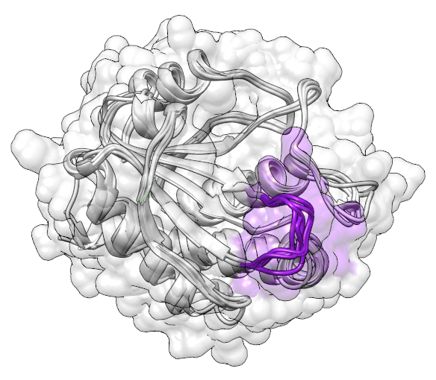 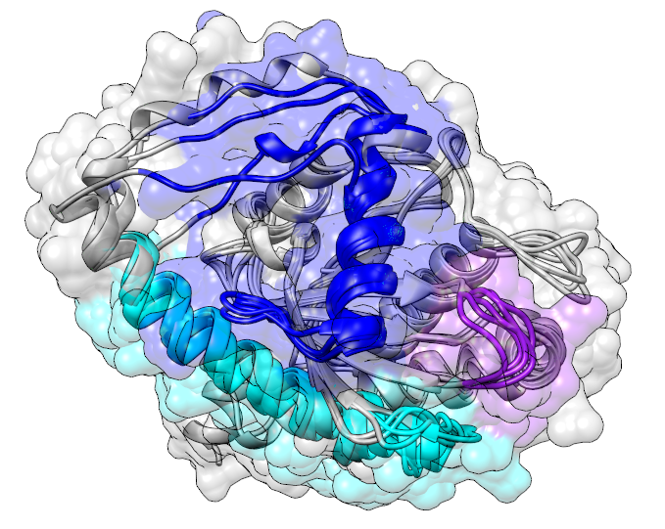 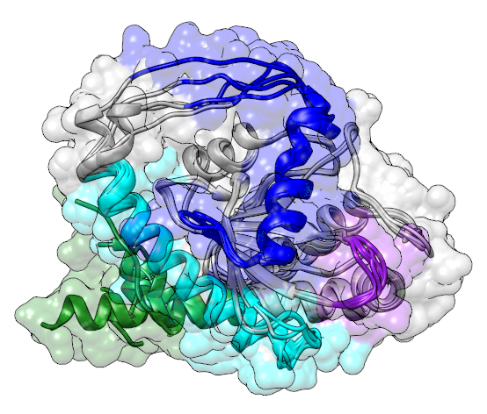

**B**

**C**

**A**

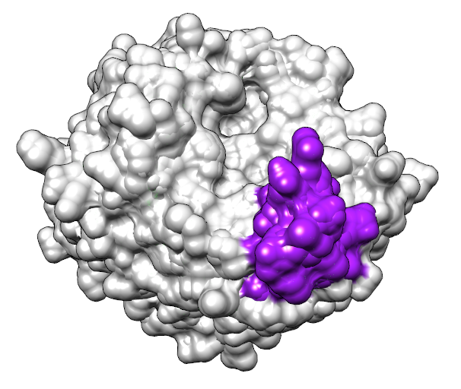 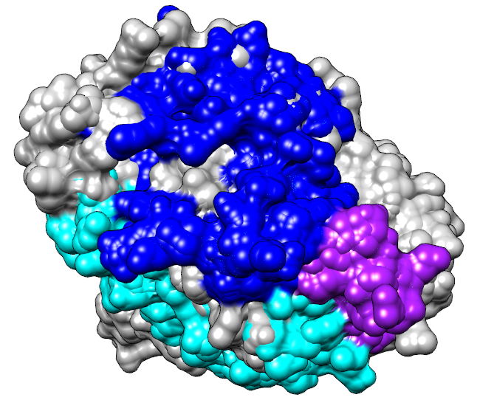 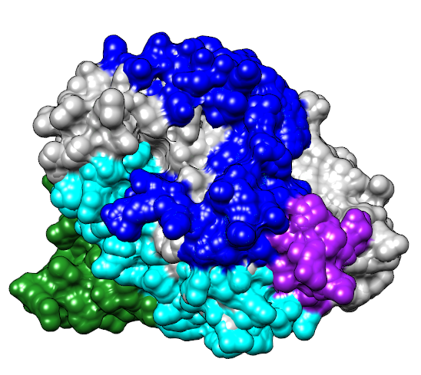

**E**

**F**

**D**

### 3.4.3 I-2 and I-4 Insertions

The structures for I-2 and I-4 containing NAMLAA notably contain the Amidase 3 domain plus a long region of disorder which AlphaFold3 failed to predict (Figure 11A). Once these were cropped to the Amidase 3 domain only, I-2 corresponds to a complex loop structure around the upper edge of the active site region without blocking it, containing a β hairpin, and an additional small α-helix consisting of 2-3 tight turns. I-4 corresponds to a short loop which folds adjacent to I-2 (Figure 11B, 11C). From their predicted proximity, and appearing together frequently across the totality of the sequence dataset, these two insertion regions may work in tandem, and given their position on the outside of the enzyme, they may assist in cofactor/co-enzyme binding.

**Figure 11: Structural predictions for sequences containing I-4**. A: Full structures for five sequences containing both I-2 and I-4, structure coloured by pLDDT score (orange = <40, yellow = <50, light blue = <70, dark blue = <90). B: Cropped Amidase 3 predictions aligned for five structures containing both I-2 and I-4. C: Cropped Amidase 3 predictions aligned for 5 structures containing I-5 and I-4 without I-2. D: Cropped Amidase 3 predictions aligned for 5 structures containing I-4, I-5 and I-6. Structures B-D are repeated and shown with full surface modelling on the bottom row (E-G) For structures B-F: I-2 is coloured orange, I-4 is coloured yellow, I-5 is purple, and I-6 is dark blue.

**A**

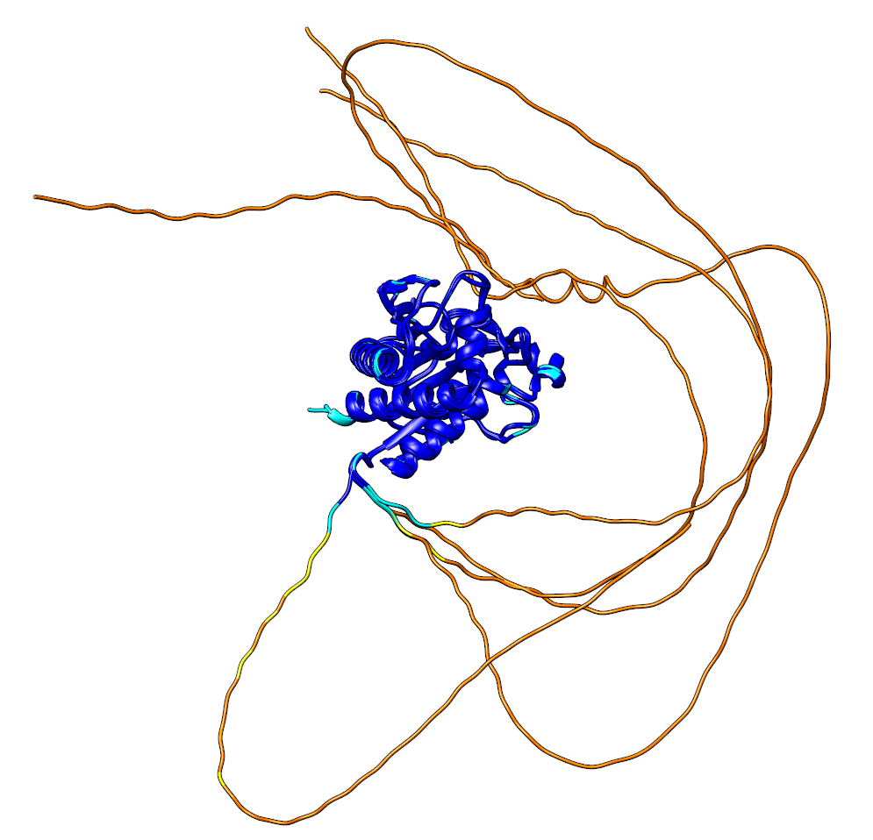

**B**

**C**

**D**

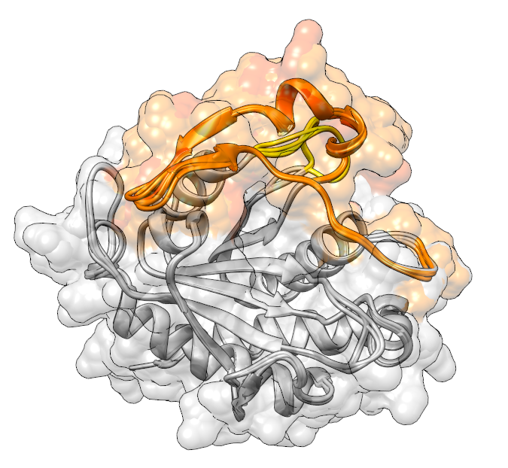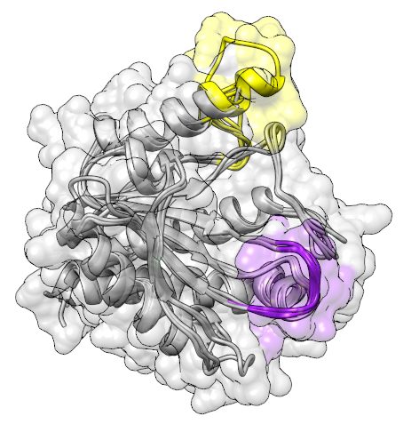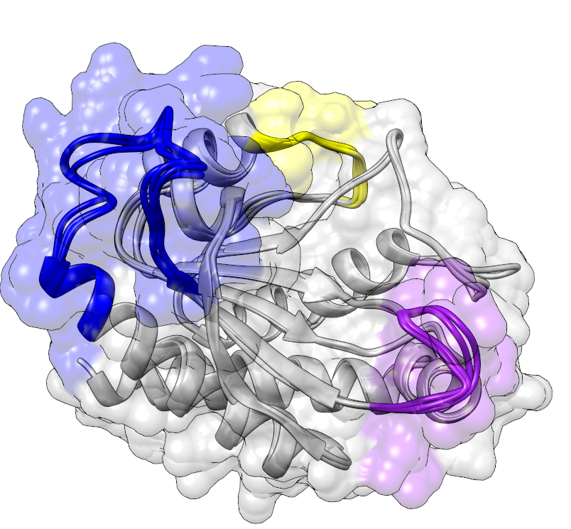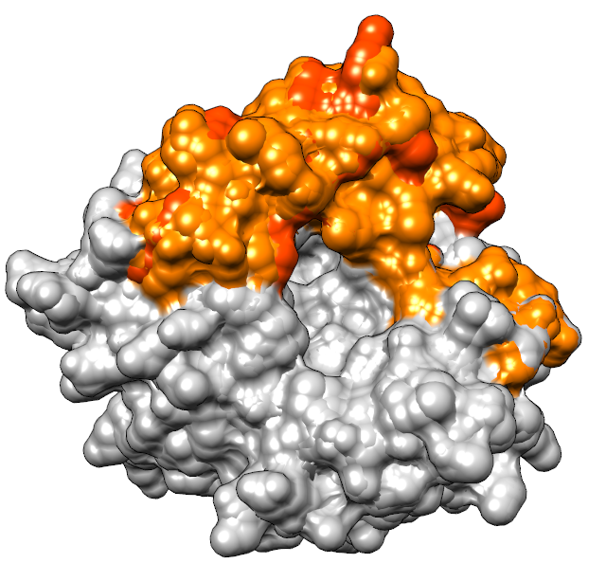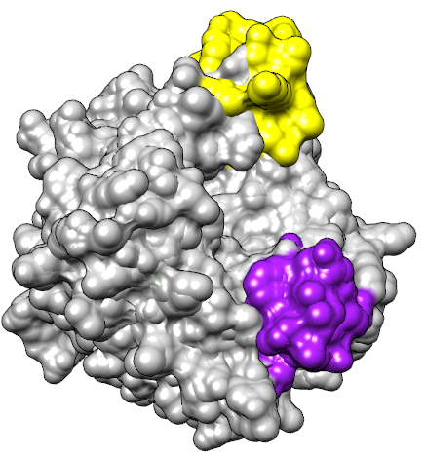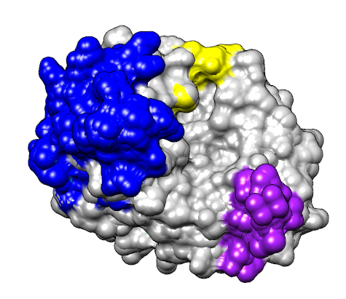

**G**

**F**

**E**

When I-5 is present alongside I-4, I-4 takes on a different position in space, looping up into the position I-2 usually occupies and forming the top ‘lip’ of the active site in its place. An additional fold appears on the left of the active site, forming a third ‘lip’, however rather than being a new insertion, this is folded from existing structure (Figure 11D, 11E).

When I-6 and I-4 co-occur (although only 55 sequences contain both I-4 and I-6 (Figure 7)), the I-6 region appears in a different location. Rather than being positioned within the active site cavity, the insertion instead folds on the exterior of the protein away from the active site (Figure 11F, 11G). This perhaps indicates a structural function of I-4 which prevents the I-6 insertion from blocking the active site, keeping the enzyme activated.

The I-2 and I-6 regions can be found together, but are very rare in the dataset (present in 36 sequences). One such example, *Campylobacter_novaezeelandiae,* is predicted to have the I-2, I-5, I-6, and I-7 regions. The structure, unlike the other structures presented thus far, has regions of poor confidence (pLDDT <50) in the Amidase 3 structure itself, specifically where the I-6 and I-2 insertions would be (Figure 12). Given the poor confidence in prediction, it is difficult to draw conclusions regarding the true locations of I-2 and I-6 in this structure.

**Figure 12: Example structures containing the I-2 region.** Structures coloured by pLDDT for A: 5 structures with I-2 and no I-6, and B: Campylobacter_novaezeelandiae NAMLAA, which has both I-2 and I-6.

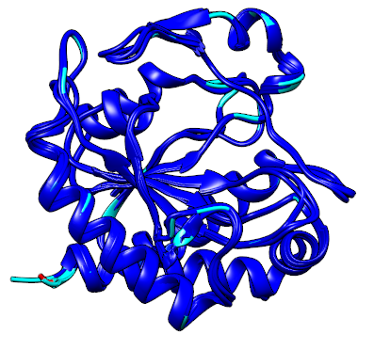 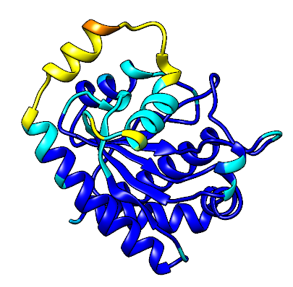

**B**

**A**

### 3.4.4 Other insertions

I-3 is the smallest predicted insertion, and when mapping this to five candidate structures containing only this insertion, the region corresponds to a small loop connecting an alpha helix to a single beta pleat. (Figure 13A). Despite I-3 having a similar loading score to I-2 in PC1, given the small size of this insertion and the fact that it does not appear to be linked to any particular structural difference, it may be that this insertion is an artefact of the insertion identification algorithm rather than a true insertion. This also aligns with the ‘insertion’ being present in the majority of species in the representative phylogeny, much like I-8.

**Figure 13: Structures predicted for cropped Amidase 3 structures containing I-3.** A: Structures with the I-3 region only. B: Structures with both I-3 and I-5.

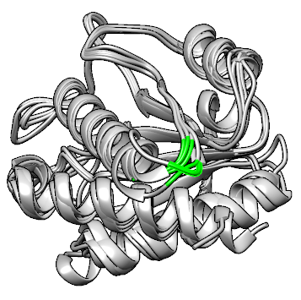 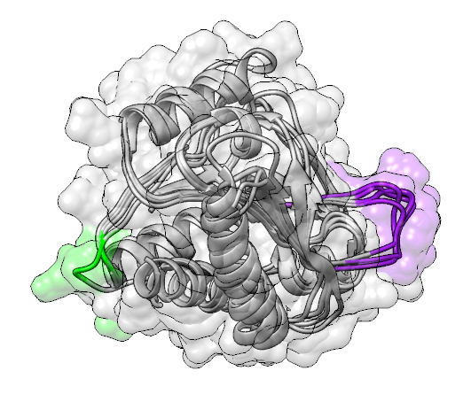

**A**

**B**

I-1 was not common within the dataset, and appeared only alongside other insertions. To investigate this insertion, one gram-positive structure (from *Lysinibacillus halotolerans*, I-1 and I-5 insertions) and one gram-negative structure (from *Rodentibacter pneumotropicus*, I-1, I-6 and I-7 insertions) were selected for prediction. These structures did not appear different from the structures containing I-5 or I-6 and I-7 respectively, and so much like I-8 the I-1 region might be an artefact of domain boundary cropping.

### 3.4.5 Re-grouping based on impactful insertions

Acknowledging that regions I-1, I-3 and I-8 may not be ‘true’ evolutionary insertions given the structural predictions and general prevalence across all species in the representative phylogeny, the sequences can be effectively regrouped according to the remaining regions. This re-grouping reveals that sequences with an I-5, I-6 and I-7 insertion are hugely over-represented in the sequence set, with 10,882 sequences fitting this profile (Figure 14). 3,134 sequences have only an I-5 insertion, followed in prevalence by sequences with an I-4 and/or an I-2 insertion. 1,062 sequences do not have any identified insertion sequence.

**Figure 14: Adjusted summary boxplot of 21 binary fingerprint clusters present in the overall sequence dataset of 20,304 sequences.** Binary fingerprints indicate presence of an insertion region, in order: I-2, I-4, I-5, I-6, I-7.

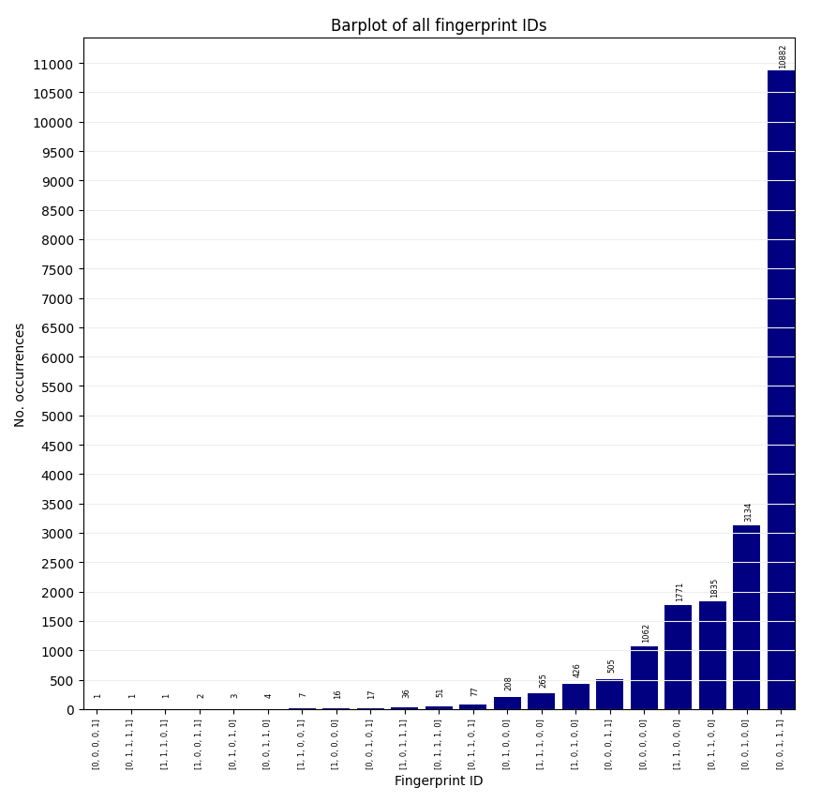

# 4 Discussion

NAMLAA proteins are zinc-dependant amidases containing the Amidase 3 catalytic domain, which present across the bacterial kingdom and have been shown to play a key role in cell wall lysis by way of peptidoglycan re-modelling and re-cycling. While the majority of structural focus in current literature has focused on NAMLAA in common bacteria such as *E. coli*, experimental structures and research across the kingdom is generally sparse. Previous work has revealed the presence of a helix which blocks the active site of NAMLAA in *B. henselae* and *E. coli*, also dubbed the ‘auto-inhibitory helix’, and has a role which has been shown to prevent amidase activity until moved out of the active site by ligand or allosteric binding to the protein5,16,20. However, when looking across the spectrum of available structures and sequences associated with NAMLAA, it has become clear that this is not the only mechanism available for inhibition of NAMLAA, and in fact evolutionary changes to NAMLAA associated to specific genus of bacteria may reveal NAMLAA roles in related but different processes.

### 4.1 Ami-A like experimental structures are distinct from AmiC-like structures

5 AmiA-like structures (2IM9, 2P1G, 4H4J, 4Q5K, 4Q68), if indeed are the same domain as the 19 candidate NAMLAA, should have had similar scores and aligned well. However, RMSD was higher than 3 for all five structures, and Q-score was less than 0.1. These are poor scores, alongside the statistically significant one-way ANOVA, shows that these 5 structures - despite being identified through searches for NAMLAA – are indeed distinct from the highly conserved structures of the Amidase 3 enzymes. There is also difference shown in the secondary structure, which perhaps is the cause of the poorer quality scores, and also notable that these did not appear in initial similarity searches and do not have a zinc ion ligand listed in their PDB entries list the others, instead having a sodium ion. Previous research has suggested the three *E.coli* NAMLAA (AmiA, AmiB, and AmiC) are redundant and have the same function4,17,87, therefore it follows that these AmiA-like amidases should be structurally equivalent to the AmiC homologues. Instead, these five structures are linked to an alternative protein family, DUF1460, which have amidase function and are described as NAMLAA in prior publications88, however the significant structural differences may warrant further investigation into this group as a separate amidase family.

### 4.2 Presence of a highly-prevalent auto-inhibitory helix separates gram-negative NAMLAA from gram-positive

A recent study published structures of the active AmiB-Env-LytM structure in *E.coli*; functionally, this study proposed that AmiB is activated by binding of the helix to the LytM factor5. When ‘active’, the helix which maps to the I-6 region is moved out of the active site, and the folding of helices and loops around the amidase active sites begins to resemble the predicted structure of sequences containing I-4 and I-6. This could indicate that when the I-4 region is present, particularly with the I-6 region, the enzyme is no longer inhibited by the I-6 helix and is therefore active, providing evidence of the auto-inhibitory function of the I-6 helix.

When the initial 19 structures on the shortlist were aligned with PDBeFOLD and USAlign, only 3NE8 and 4BIN contained the auto-inhibitory helix region. Expanding this search across all available sequences, around half of all sequences (11,484 sequences) were found to contain the I-6 region – a region which maps to the auto-inhibitory helix - and the most prevalent cluster overall contained I-5, I-6 and I-7 (10,882 sequences).

Further annotating clustered sequences by ‘gram-negative’ and ‘gram-positive’ shows that a large majority of sequences with the I-6 and I-7 insertion are predicted to have a thick peptidoglycan cell wall (gram-negative), while gram-positive tend to have the I-2 and I-4 insertions. The I-6 region maps to the auto-inhibitory helix, supporting the hypothesis that this helix is relevant for a function in gram-negative bacteria which is not utilised in gram-positive. This is further displayed in the representative phylogeny, where the gram negative phyla *Pseudomonadota* and *Bacteroidota* cluster together with a recent common ancestor compared to gram-positive phyla.

Additional evidence of the insertion regions clustering species according to their major phyla was obtained using PCA. Insertion regions separate the species into two main clusters with the first two PCs, which correspond to gram-positive and gram-negative phyla, however separation is not perfect with some gram-negative species clustering with the gram-positive phyla. The PCA showed additional separation of gram-positive phyla *Actinomycetota* and *Bacillota*. From the biplot, *Actinomycetota* is associated with I-2 and I-4, and given that I-1 and I-3 are unlikely to be 'true' insertions, this leaves the *Bacillota* cluster associated with no insertions (which is also demonstrated in the fingerprint clustering, where 999/1062 of sequences with no insertions belonged to the *Bacillota* phylum).

### 4.3 Not all gram-negative NAMLAA are controlled by an auto-inhibitory helix

The alignment also showed the additional helix for 4BIN and 3NE8, as previously described. However, 3CZX (from *Neisseria meningitidis*), NAMLAA from another gram-negative bacteria, lacked the auto-inhibitory helix. In sequence analysis, this sequence is predicted to have an I-5, I-6 and I-7 insertion, hence containing an auto-inhibitory helix, and the experimental structure 3CZX also does appear to have at least a partial helix structure over the expected active site (consisting of a loop positioned over the bound zin ion), although the structure differs to the full I-6 insertion in that it resembles a helix-turn-helix more than a single helix. It is possible that NAMLAA in *Neisseria* species have alternative activity in other pathways, as shown in *Neiserria gonorrhoeae*, where AmiC was shown to have both cell wall lytic and autolytic behaviour18.

Upon clustering this pattern was repeated for the full sequence dataset, many gram-negative bacteria cluster in groups without the I-6 helix (for example, 560 *Cyanobacteriota* clustering with gram positive bacteria in the 3134-sequence I-5 only cluster). A similar pattern is seen for the I-7 region, which a large number of gram-negative bacteria have but which *Cyanobacteriota* lack. This again indicates multiple mechanisms for activation of NAMLAA in gram negative bacteria other than the auto-inhibitory helix, despite this being fairly prevalent across several NAMLAA structures as described by Yang et al. in 201220. Interestingly, *Cyanobacteriota* have a unique cell wall structure to other typical gram-negative bacteria such as *Escherichia coli* (which has been shown to have several NAMLAA with the autoinhibitory helix16,20 – *Cyanobacteria* have a particularly thick cell wall characterised by cross-linking, and still require NAMLAA for remodelling and recycling of the peptidoglycan cell wall, despite lacking the auto-inhibitory helix of *E. coli* NAMLAA, however recent work has suggested that cell wall separation is regulated using an alternative mechanism using small RNA Yfr1 in *Cyanobacteria*, which suggests an alternative inhibition/promotion pathway that may not require the auto-inhibitory helix.89,90

### 4.4 NAMLAA Activity in gram-positive species

For gram-negative bacteria, cell-wall separation would require auto-inhibition to prevent the enzyme from dismantling the entire bacterial cell wall rather than just the septal ring. For gram-positive bacteria – which do not have the same cell wall separation mechanism – the enzyme may be required for a different reason that may not require such ‘switching off’. It would not be useful, for example, for an enzyme designed to kill neighbouring or parent bacterial cells to have an inhibition helix, since the goal would be complete breakdown of the cell wall rather than carefully controlled action.

When present without the I-2 insertion, the I-4 region asserts into the same space adjacent to the active site, and produces a new structure, with a different shape around the Zn2+ binding site. Prevalent in this group are *Bacillus* species (I-4 and I-5 cluster: 772/1835) (I-4 only cluster: 59/208) and *Clostridium* species (I-4 and I-5: 144/1835) (I-4: 45/208). Given that these species are gram-positive staining, with a cell wall structure (and therefore cell division pathway_ separate to that of gram-negative bacteria, it is likely that NAMLAA in this group have an alternative function to cell wall lysis. One candidate for this alternative function may be as part of sporulation, which both the *Bacillus* and *Clostridium* genera are associated with.91

During sporulation, asymmetric cell division takes place, in which the developing prespore is engulfed by the mother cell within a double-layered peptidoglycan membrane with an inner and outer membrane. The engulfed spore inner membrane is a thin layer of peptidoglycan, similar to the final mature cell, and the outer membrane is composed of a different peptidoglycan type which is much thicker.91,92 This assembly of thick peptidoglycan is reminiscent of gram-negative wall formation, and specifically, in *B. subtilis* spores it has been noted that the peptidoglycan in the thicker outer membrane contains a quarter of N-acetylmuramic acid residues carrying an L-alanine residue which is not present in the inner membrane or germ cell wall93,94. Further evidence of NAMLAA involvement is shown in the *B. subtilis* spore germination pathway, where two lytic enzymes CwlJ and SleB hydrolyse the outer cell wall (the ‘cortex’) without destroying the germ cell wall95. CwlJ in particular has previously been proposed to have NAMLAA activity in *B. anthracis*96–98. A similar role has been shown for CwlD in spore cortex degradation in *Clostridioides difficile*19. In this role, the NAMLAA would not need an auto-inhibitory helix; in theory, the enzyme would be expressed solely to dismantle the thicker peptidoglycan wall as part of spore germination, and since the inner cell wall does not contain peptidoglycan with the L-alanine residue modification, there would be no risk of destroying the new endospore. This supports the clustering of such ‘active’ NAMLAA structures which lack the auto-inhibitory helix in species which sporulate, however further experiments into the function of NAMLAA in these species would be required to validate this.

### 4.5 An alternative pathway for NAMLAA involvement in *Mycobacterium*

4M6H and 4M6G are Zn2+ bound andZn2+un-boundstructures isolated from *Mycobacterium tuberculosis*. In the bound state, formation of a disulphide bond within the active site promotes folding of the region 'ANDASIGRQVPTGRGGTKNCQASG' into an additional β-hairpin structure beside the active site72. The candidate structural alignment in PDBeFOLD showed several structures all isolated from *Mycobacterium* and *Mycolicibacterium* species with this same β-hairpin towards the start of the sequence (4LQ6, 4M6G, 7AGL, 7AGM, and 7AGO).

This β-hairpin structure in the activated Zn2+ bound structure resembles the predicted I-2 region both in structure and position, lending further credence to the theory that structures with the I-2 and I-4 insertions are 'active' forms of the protein. However, interestingly, the non-active unbound form of the protein lacks an additional ‘I-6’ helix within the Zn2+ binding site. Clustering of species containing I-2 and I-4 reveals 170/1771 *Mycobacterium* species and 103/1771 *Mycolicibacterium*, alongside 1010/1771 *Streptomyces*. These *Actinomycetota* species also cluster together on the representative phylogenetic tree (Appendix H). This is notable in that the *Streptomyces* genus is also associated with sporulation and generation of a spore wall, which potentially indicates a similar mechanism of sporulation in these *Mycobacterium* species - this has been a controversial topic in previous literature, with debate regarding if spore presence in *Mycobacterium* samples are truly spores from that genus or are from contaminants, with spore formation not consistently replicated under laboratory conditions99,100. Indeed, many of the *Mycobacterium* samples in this dataset originated from environmental UniProt samples which are not immune to contamination. Even so, the fact that NAMLAA from so many *Mycobacterium* species clustered with *Streptomyces* species, and that *Streptomyces* NAMLAA are likely involved in an alternative pathway such as sporulation given the structural and functional activation differences between these NAMLAA and NAMLAA from gram-negative species which are involved in cell wall separation, the possibility of a mechanistic similarity and mycobacterial sporulation should not be ignored - some *Mycobacterium* species have already been recently been associated with both *Streptomyces* and endospore-forming bacteria such as *Bacillus subtilis* through comparison of key genetic pathway markers101, and given structural similarities additionally shown with NAMLAA here, there may be further genes which connect these species through the sporulation pathway.

### 4.6 NAMLAA activity in bacteriophage species

Bacteriophage species were rare in the sequence dataset, however where included as a potential endolytic role for NAMLAA may be in destruction of bacterial cell wall to induce cell death if produced by a bacteriophage20,21. Three structures from bacteriophages were included in the initial sequence searches (3QAY, 7B3N, 1XOV), however after alignment and filtering, only the sequence from 1XOV was retained, and only 17 bacteriophage species in total were in the final data. This indicates bacteriophage sequences are dissimilar to NAMLAA in bacteria, whilst retaining enough similarity to still be clustered in small numbers.

These sequences all clustered into the I-2 group (17/17) and lacked the auto-inhibitory helix, however the role for bacteriophages in cell wall lysis would not necessitate an inhibition function, since NAMLAA would only be needed to ‘lyse’ the bacterial cell wall to release the new viral particles12,62. Clustering with these bacteriophages are *Cyanobacteriota* (50/208) and gram-positive *Bacillota* (138/208), showing a link between NAMLAA structures which are not automatically inhibited and the bacteriophage NAMLAA homologs.

### 4.7 Limitations

Due to low sequence identity when conducting the BLASTp searches, it is possible that some sequences included in the multiple sequence alignment are not true AmiC homologues, an assumption on which the final phylogeny and conclusions regarding the auto-inhibitory helix is based. The methodology presented here has adjusted for this unknown quantity in defining NAMLAA by adding several quality filtering steps, and validated the final alignment using a structural alignment of candidate AmiC structures – which demonstrated high conservation of structure despite low conservation of sequence between NAMLAA. One quality filtering step removed sequences which induced large gaps in the alignment that contained information from very few sequences. This was because the initial structure alignment between AmiC homologues and another domain type annotated as ‘AmiA’-like’ showed that including AmiA-like proteins added large gaps, therefore it follows that sequences introducing large gaps in the alignment may belong to other protein domains. Higher certainty that the final alignment contains sequences only from NAMLAA would be attained by validating with more experimental structures that have a confirmed NAMLAA role within bacterial cells (e.g. cell wall lysis), however at this time further experimental structures are not available.

The multiple sequence alignment was generated using only one tool (kalign-3) due to size of sequence dataset; computational time for several other tools was too high to complete the alignment. This means that the algorithm used to identify poorly conserved regions (which is based on gap identification across the dataset) was tested on only one alignment, resulting in low-confidence ‘insertion regions’ (I-1, I-3, I-8) and other insertion region boundaries based on a single alignment that potentially may differ if using a different alignment algorithm. The algorithm was designed to identify insertion regions of multiple positions because low sequence identity in the protein family may lead to individual gap-rich positions being opened to align the sequences (which would not be ‘true’ insertion regions), however given that some ‘conserved regions’ identified by the insertion region algorithm contained 1- or 2-wide positions of low conservations, having alternative alignments to validate these insertion regions and their boundaries would have been beneficial to ensure no smaller insertion regions are missed. Repetition of the multiple sequence alignment with other tools would be useful in validating the algorithm findings as new methodology for alignment is developed, relying on different methods that can accommodate large sequence datasets.

As short-hand for differing cell wall structure, each species was defined as ‘gram-negative’ or ‘gram-positive’ These definitions are non-exact where staining experiments have not been conducted, and boundaries can be blurred (e.g. *Mycobacterium tuberculosis*). For this research, as universal testing data was not available, ‘gram-positive’ and ‘gram-negative’ designation was based on species phyla. There is a chance that some of the enzymes have been mis-classified as the wrong species, especially for WGS shotgun sequences from InterPro. To limit this, a quality filter was applied to preferentially include sequences from species that had been curated for the RefSeq database.

### 4.8 Potential next steps

Many of the discussed bacteria are pathogenic in humans, and inhibition of NAMLAA in these species could result in cell lytic arrest during bacterial replication, in both septal wall lysis in gram-negative staining bacteria, or in spore germination for other species. The auto-inhibitory helix in gram-negative bacteria has previously been shown to inhibit lytic activity, and as such, development of an irreversible inhibitor blocking the active site in NAMLAA similarly to this helix region may be beneficial in targeting such pathogenic bacteria and preventing cell replication. Future work might also focus on elucidating alternative inhibition pathways involved in the cell lysis pathway, and further experimental investigation into confirming the proposed role of NAMLAA in gram-positive bacteria.

# 5 Conclusion

While highly conserved across species, NAMLAA contain several insertions which mark evolutionary differences between bacterial phyla and potentially act as markers for differentiating NAMLAA by function, including their well-documented role in cell wall lysis, but also potentially playing a role in bacterial sporulation and endolytic activity. Of note, this work has demonstrated the high prevalence of the auto-inhibitory helix in many gram-negative staining species sequences and structures, and also proposed a role for NAMLAA in gram-positive species, including a link to sporulating function in *Bacillus*, *Clostridium*, *Streptomyces*, and *Mycobacterium* species.

# References

1. Berman, H.M., Westbrook, J., Feng, Z., Gilliland, G., Bhat, T.N., Weissig, H., Shindyalov, I.N., and Bourne, P.E. (2000). The Protein Data Bank. Nucleic Acids Res. *28*, 235–242. https://doi.org/10.1093/nar/28.1.235.

2. Vollmer, W., Blanot, D., and De Pedro, M.A. (2008). Peptidoglycan structure and architecture. FEMS Microbiol. Rev. *32*, 149–167. https://doi.org/10.1111/j.1574-6976.2007.00094.x.

3. Garde, S., Chodisetti, P.K., and Reddy, M. Peptidoglycan: Structure, Synthesis, and Regulation. EcoSal Plus *9*, eESP-0010-2020. https://doi.org/10.1128/ecosalplus.ESP-0010-2020.

4. Heidrich, C., Templin, M.F., Ursinus, A., Merdanovic, M., Berger, J., Schwarz, H., de Pedro, M.A., and Höltje, J.V. (2001). Involvement of N-acetylmuramyl-L-alanine amidases in cell separation and antibiotic-induced autolysis of Escherichia coli. Mol. Microbiol. *41*, 167–178. https://doi.org/10.1046/j.1365-2958.2001.02499.x.

5. Cook, J., Baverstock, T.C., McAndrew, M.B.L., Roper, D.I., Stansfeld, P.J., and Crow, A. (2023). Activator-induced conformational changes regulate division-associated peptidoglycan amidases. Proc. Natl. Acad. Sci. *120*, e2302580120. https://doi.org/10.1073/pnas.2302580120.

6. de Boer, P.A.J. (2010). Advances in understanding E.coli cell fission. Curr. Opin. Microbiol. *13*, 730–737. https://doi.org/10.1016/j.mib.2010.09.015.

7. Bi, E.F., and Lutkenhaus, J. (1991). FtsZ ring structure associated with division in Escherichia coli. Nature *354*, 161–164. https://doi.org/10.1038/354161a0.

8. Wissel, M.C., and Weiss, D.S. (2004). Genetic Analysis of the Cell Division Protein FtsI (PBP3): Amino Acid Substitutions That Impair Septal Localization of FtsI and Recruitment of FtsN. J. Bacteriol. *186*, 490–502. https://doi.org/10.1128/JB.186.2.490-502.2004.

9. Priyadarshini, R., de Pedro, M.A., and Young, K.D. (2007). Role of Peptidoglycan Amidases in the Development and Morphology of the Division Septum in Escherichia coli. J. Bacteriol. *189*, 5334–5347. https://doi.org/10.1128/JB.00415-07.

10. Peters, N.T., Dinh, T., and Bernhardt, T.G. (2011). A Fail-Safe Mechanism in the Septal Ring Assembly Pathway Generated by the Sequential Recruitment of Cell Separation Amidases and Their Activators. J. Bacteriol. *193*, 4973–4983. https://doi.org/10.1128/JB.00316-11.

11. Uehara, T., and Park, J.T. (2007). An Anhydro-N-Acetylmuramyl-l-Alanine Amidase with Broad Specificity Tethered to the Outer Membrane of Escherichia coli. J. Bacteriol. *189*, 5634–5641. https://doi.org/10.1128/jb.00446-07.

12. Vermassen, A., Leroy, S., Talon, R., Provot, C., Popowska, M., and Desvaux, M. (2019). Cell Wall Hydrolases in Bacteria: Insight on the Diversity of Cell Wall Amidases, Glycosidases and Peptidases Toward Peptidoglycan. Front. Microbiol. *10*, 331. https://doi.org/10.3389/fmicb.2019.00331.

13. Büttner, F.M., Faulhaber, K., Forchhammer, K., Maldener, I., and Stehle, T. (2016). Enabling cell–cell communication via nanopore formation: structure, function and localization of the unique cell wall amidase AmiC2 of Nostoc punctiforme. FEBS J. *283*, 1336–1350. https://doi.org/10.1111/febs.13673.

14. Kumar, A., Kumar, S., Kumar, D., Mishra, A., Dewangan, R.P., Shrivastava, P., Ramachandran, S., and Taneja, B. (2013). The structure of Rv3717 reveals a novel amidase from Mycobacterium tuberculosis. Acta Crystallogr. D Biol. Crystallogr. *69*, 2543–2554. https://doi.org/10.1107/S0907444913026371.

15. Firczuk, M., and Bochtler, M. (2007). Folds and activities of peptidoglycan amidases. FEMS Microbiol. Rev. *31*, 676–691. https://doi.org/10.1111/j.1574-6976.2007.00084.x.

16. Rocaboy, M., Herman, R., Sauvage, E., Remaut, H., Moonens, K., Terrak, M., Charlier, P., and Kerff, F. (2013). The crystal structure of the cell division amidase AmiC reveals the fold of the AMIN domain, a new peptidoglycan binding domain. Mol. Microbiol. *90*, 267–277. https://doi.org/10.1111/mmi.12361.

17. Kerff, F., Petrella, S., Mercier, F., Sauvage, E., Herman, R., Pennartz, A., Zervosen, A., Luxen, A., Frère, J.-M., Joris, B., et al. (2010). Specific structural features of the N-acetylmuramoyl-L-alanine amidase AmiD from Escherichia coli and mechanistic implications for enzymes of this family. J. Mol. Biol. *397*, 249–259. https://doi.org/10.1016/j.jmb.2009.12.038.

18. Garcia, D.L., and Dillard, J.P. (2006). AmiC functions as an N-acetylmuramyl-l-alanine amidase necessary for cell separation and can promote autolysis in Neisseria gonorrhoeae. J. Bacteriol. *188*, 7211–7221. https://doi.org/10.1128/JB.00724-06.

19. Feliciano, C.A., Eckenroth, B.E., Diaz, O.R., Doublié, S., and Shen, A. (2021). A lipoprotein allosterically activates the CwlD amidase during Clostridioides difficile spore formation. PLOS Genet. *17*, e1009791. https://doi.org/10.1371/journal.pgen.1009791.

20. Yang, D.C., Tan, K., Joachimiak, A., and Bernhardt, T.G. (2012). A conformational switch controls cell wall-remodelling enzymes required for bacterial cell division. Mol. Microbiol. *85*, 768–781. https://doi.org/10.1111/j.1365-2958.2012.08138.x.

21. Korndörfer, I.P., Danzer, J., Schmelcher, M., Zimmer, M., Skerra, A., and Loessner, M.J. (2006). The Crystal Structure of the Bacteriophage PSA Endolysin Reveals a Unique Fold Responsible for Specific Recognition of Listeria Cell Walls. J. Mol. Biol. *364*, 678–689. https://doi.org/10.1016/j.jmb.2006.08.069.

22. Hoijer, M.A., Melief, M.J., Calafat, J., Roos, D., van den Beemd, R.W.M., van Dongen, J.J.M., and Hazenberg, M.P. (1997). Expression and Intracellular Localization of the Human N-acetylmuramyl-L-alanine Amidase, a Bacterial Cell Wall–Degrading Enzyme. Blood *90*, 1246–1254. https://doi.org/10.1182/blood.V90.3.1246.

23. Kerff, F., Rocaboy, M., Herman, R., Sauvage, E., and Charlier, P. (2013). Crystal structure of the E. coli N-acetylmuramoyl-L-alanine amidase AmiC. https://doi.org/10.2210/pdb4bin/pdb.

24. Altschul, S.F., Gish, W., Miller, W., Myers, E.W., and Lipman, D.J. (1990). Basic local alignment search tool. J. Mol. Biol. *215*, 403–410. https://doi.org/10.1016/S0022-2836(05)80360-2.

25. Andreeva, A., Howorth, D., Chothia, C., Kulesha, E., and Murzin, A.G. (2014). SCOP2 prototype: a new approach to protein structure mining. Nucleic Acids Res. *42*, D310–D314. https://doi.org/10.1093/nar/gkt1242.

26. Andreeva, A., Kulesha, E., Gough, J., and Murzin, A.G. (2020). The SCOP database in 2020: expanded classification of representative family and superfamily domains of known protein structures. Nucleic Acids Res. *48*, D376–D382. https://doi.org/10.1093/nar/gkz1064.

27. Mistry, J., Chuguransky, S., Williams, L., Qureshi, M., Salazar, G.A., Sonnhammer, E.L.L., Tosatto, S.C.E., Paladin, L., Raj, S., Richardson, L.J., et al. (2021). Pfam: The protein families database in 2021. Nucleic Acids Res. *49*, D412–D419. https://doi.org/10.1093/nar/gkaa913.

28. Paysan-Lafosse, T., Blum, M., Chuguransky, S., Grego, T., Pinto, B.L., Salazar, G.A., Bileschi, M.L., Bork, P., Bridge, A., Colwell, L., et al. (2023). InterPro in 2022. Nucleic Acids Res. *51*, D418–D427. https://doi.org/10.1093/nar/gkac993.

29. Ashburner, M., Ball, C.A., Blake, J.A., Botstein, D., Butler, H., Cherry, J.M., Davis, A.P., Dolinski, K., Dwight, S.S., Eppig, J.T., et al. (2000). Gene Ontology: tool for the unification of biology. Nat. Genet. *25*, 25–29. https://doi.org/10.1038/75556.

30. The Gene Ontology Consortium, Aleksander, S.A., Balhoff, J., Carbon, S., Cherry, J.M., Drabkin, H.J., Ebert, D., Feuermann, M., Gaudet, P., Harris, N.L., et al. (2023). The Gene Ontology knowledgebase in 2023. Genetics *224*, iyad031. https://doi.org/10.1093/genetics/iyad031.

31. Pettersen, E.F., Goddard, T.D., Huang, C.C., Couch, G.S., Greenblatt, D.M., Meng, E.C., and Ferrin, T.E. (2004). UCSF Chimera--a visualization system for exploratory research and analysis. J. Comput. Chem. *25*, 1605–1612. https://doi.org/10.1002/jcc.20084.

32. Meng, E.C., Pettersen, E.F., Couch, G.S., Huang, C.C., and Ferrin, T.E. (2006). Tools for integrated sequence-structure analysis with UCSF Chimera. BMC Bioinformatics *7*, 339. https://doi.org/10.1186/1471-2105-7-339.

33. Krissinel, E., and Henrick, K. (2004). Secondary-structure matching (SSM), a new tool for fast protein structure alignment in three dimensions. Acta Crystallogr. D Biol. Crystallogr. *60*, 2256–2268. https://doi.org/10.1107/S0907444904026460.

34. Krissinel, E., and Henrick, K. (2005). Multiple Alignment of Protein Structures in Three Dimensions. In Computational Life Sciences, M. R. Berthold, R. C. Glen, K. Diederichs, O. Kohlbacher, and I. Fischer, eds. (Springer), pp. 67–78. https://doi.org/10.1007/11560500_7.

35. Zhang, C., Shine, M., Pyle, A.M., and Zhang, Y. (2022). US-align: universal structure alignments of proteins, nucleic acids, and macromolecular complexes. Nat. Methods *19*, 1109–1115. https://doi.org/10.1038/s41592-022-01585-1.

36. O’Leary, N.A., Wright, M.W., Brister, J.R., Ciufo, S., Haddad, D., McVeigh, R., Rajput, B., Robbertse, B., Smith-White, B., Ako-Adjei, D., et al. (2016). Reference sequence (RefSeq) database at NCBI: current status, taxonomic expansion, and functional annotation. Nucleic Acids Res. *44*, D733-745. https://doi.org/10.1093/nar/gkv1189.

37. Cock, P.J.A., Antao, T., Chang, J.T., Chapman, B.A., Cox, C.J., Dalke, A., Friedberg, I., Hamelryck, T., Kauff, F., Wilczynski, B., et al. (2009). Biopython: freely available Python tools for computational molecular biology and bioinformatics. Bioinformatics *25*, 1422–1423. https://doi.org/10.1093/bioinformatics/btp163.

38. Finn, R.D., Clements, J., and Eddy, S.R. (2011). HMMER web server: interactive sequence similarity searching. Nucleic Acids Res. *39*, W29–W37. https://doi.org/10.1093/nar/gkr367.

39. Sayers, E.W., Bolton, E.E., Brister, J.R., Canese, K., Chan, J., Comeau, D.C., Connor, R., Funk, K., Kelly, C., Kim, S., et al. (2022). Database resources of the national center for biotechnology information. Nucleic Acids Res. *50*, D20–D26. https://doi.org/10.1093/nar/gkab1112.

40. Federhen, S. (2012). The NCBI Taxonomy database. Nucleic Acids Res. *40*, D136-143. https://doi.org/10.1093/nar/gkr1178.

41. Schoch, C.L., Ciufo, S., Domrachev, M., Hotton, C.L., Kannan, S., Khovanskaya, R., Leipe, D., Mcveigh, R., O’Neill, K., Robbertse, B., et al. (2020). NCBI Taxonomy: a comprehensive update on curation, resources and tools. Database J. Biol. Databases Curation *2020*, baaa062. https://doi.org/10.1093/database/baaa062.

42. Sakamoto, T., and Ortega, J.M. (2021). Taxallnomy: an extension of NCBI Taxonomy that produces a hierarchically complete taxonomic tree. BMC Bioinformatics *22*, 388. https://doi.org/10.1186/s12859-021-04304-3.

43. Lassmann, T. (2020). Kalign 3: multiple sequence alignment of large datasets. Bioinformatics *36*, 1928–1929. https://doi.org/10.1093/bioinformatics/btz795.

44. Jehl, P., Sievers, F., and Higgins, D.G. (2015). OD-seq: outlier detection in multiple sequence alignments. BMC Bioinformatics *16*, 269. https://doi.org/10.1186/s12859-015-0702-1.

45. Pagès, H., Aboyoun, P., Gentleman, R., and DebRoy, S. (2024). Biostrings: Efficient manipulation of biological strings. R package version 2.72.1. https://doi.org/10.18129/B9.bioc.Biostrings.

46. Waterhouse, A.M., Procter, J.B., Martin, D.M.A., Clamp, M., and Barton, G.J. (2009). Jalview Version 2—a multiple sequence alignment editor and analysis workbench. Bioinformatics *25*, 1189–1191. https://doi.org/10.1093/bioinformatics/btp033.

47. Modi, V., and Dunbrack, R.L. (2019). A Structurally-Validated Multiple Sequence Alignment of 497 Human Protein Kinase Domains. Sci. Rep. *9*, 19790. https://doi.org/10.1038/s41598-019-56499-4.

48. Hunter, J.D. (2007). Matplotlib: A 2D Graphics Environment. Comput. Sci. Eng. *9*, 90–95. https://doi.org/10.1109/MCSE.2007.55.

49. The pandas development team (2024). pandas-dev/pandas: Pandas. Version v2.2.0 (Zenodo). https://doi.org/10.5281/zenodo.10537285 https://doi.org/10.5281/zenodo.10537285.

50. Waskom, M.L. (2021). seaborn: statistical data visualization. J. Open Source Softw. *6*, 3021. https://doi.org/10.21105/joss.03021.

51. Troshin, P.V., Procter, J.B., Sherstnev, A., Barton, D.L., Madeira, F., and Barton, G.J. (2018). JABAWS 2.2 distributed web services for Bioinformatics: protein disorder, conservation and RNA secondary structure. Bioinformatics *34*, 1939–1940. https://doi.org/10.1093/bioinformatics/bty045.

52. Troshin, P.V., Procter, J.B., and Barton, G.J. (2011). Java bioinformatics analysis web services for multiple sequence alignment—JABAWS:MSA. Bioinformatics *27*, 2001–2002. https://doi.org/10.1093/bioinformatics/btr304.

53. Crooks, G.E., Hon, G., Chandonia, J.-M., and Brenner, S.E. (2004). WebLogo: A Sequence Logo Generator. Genome Res. *14*, 1188–1190. https://doi.org/10.1101/gr.849004.

54. Berends, M.S., Luz, C.F., Friedrich, A.W., Sinha, B.N.M., Albers, C.J., and Glasner, C. (2022). AMR: An R Package for Working with Antimicrobial Resistance Data. J. Stat. Softw. *104*, 1–31. https://doi.org/10.18637/jss.v104.i03.

55. Pedregosa, F., Varoquaux, G., Gramfort, A., Michel, V., Thirion, B., Grisel, O., Blondel, M., Prettenhofer, P., Weiss, R., Dubourg, V., et al. (2011). Scikit-learn: Machine Learning in Python. J. Mach. Learn. Res. *12*, 2825–2830.

56. Lefort, V., Desper, R., and Gascuel, O. (2015). FastME 2.0: A Comprehensive, Accurate, and Fast Distance-Based Phylogeny Inference Program. Mol. Biol. Evol. *32*, 2798–2800. https://doi.org/10.1093/molbev/msv150.

57. Gascuel, O. (1997). BIONJ: an improved version of the NJ algorithm based on a simple model of sequence data. Mol. Biol. Evol. *14*, 685–695. https://doi.org/10.1093/oxfordjournals.molbev.a025808.

58. Letunic, I., and Bork, P. (2024). Interactive Tree of Life (iTOL) v6: recent updates to the phylogenetic tree display and annotation tool. Nucleic Acids Res., gkae268. https://doi.org/10.1093/nar/gkae268.

59. Mirdita, M., Schütze, K., Moriwaki, Y., Heo, L., Ovchinnikov, S., and Steinegger, M. (2022). ColabFold: making protein folding accessible to all. Nat. Methods *19*, 679–682. https://doi.org/10.1038/s41592-022-01488-1.

60. Abramson, J., Adler, J., Dunger, J., Evans, R., Green, T., Pritzel, A., Ronneberger, O., Willmore, L., Ballard, A.J., Bambrick, J., et al. (2024). Accurate structure prediction of biomolecular interactions with AlphaFold 3. Nature *630*, 493–500. https://doi.org/10.1038/s41586-024-07487-w.

61. Freitag-Pohl, S., and Pohl, E. (2022). AmiP amidase-3 from Thermus parvatiensis.

62. Jasilionis, A., Plotka, M., Wang, L., Dorawa, S., Lange, J., Watzlawick, H., van den Bergh, T., Vroling, B., Altenbuchner, J., Kaczorowska, A.-K., et al. (2023). AmiP from hyperthermophilic Thermus parvatiensis prophage is a thermoactive and ultrathermostable peptidoglycan lytic amidase. Protein Sci. Publ. Protein Soc. *32*, e4585. https://doi.org/10.1002/pro.4585.

63. Zhang, R., Zhou, M., Bargassa, M., Joachimiak, A., and Midwest Center for Structural Genomics (2011). The crystal structure of the putative N-acetylmuramoyl-L-alanine amidase from Neisseria meningitidis.

64. Renko, M., Usenik, A., and Turk, D. (2017). Cwp6 from Clostridium difficile.

65. Usenik, A., Renko, M., Mihelič, M., Lindič, N., Borišek, J., Perdih, A., Pretnar, G., Müller, U., and Turk, D. (2017). The CWB2 Cell Wall-Anchoring Module Is Revealed by the Crystal Structures of the Clostridium difficile Cell Wall Proteins Cwp8 and Cwp6. Structure *25*, 514–521. https://doi.org/10.1016/j.str.2016.12.018.

66. Page, J.E., Skiba, M.A., Kruse, A.C., and Walker, S. (2022). Structure of the S. aureus amidase LytH and activator ActH extracellular domains.

67. Page, J.E., Skiba, M.A., Do, T., Kruse, A.C., and Walker, S. (2022). Metal cofactor stabilization by a partner protein is a widespread strategy employed for amidase activation. Proc. Natl. Acad. Sci. *119*, e2201141119. https://doi.org/10.1073/pnas.2201141119.

68. Tan, K., Mulligan, R., Kwon, K., Anderson, W., Joachimiak, A., and Center for Structural Genomics of Infectious Diseases (2014). The crystal structure of N-acetylmuramoyl-L-alanine amidase from Clostridium difficile 630.

69. Büttner, F.M., and Stehle, T. (2016). N-acetylmuramoyl-L-alanine amidase AmiC2 of Nostoc punctiforme.

70. Tan, K., Rakowski, E., Buck, K., Joachimiak, A., and Midwest Center for Structural Genomics (2010). The crystal structure of a domain from N-acetylmuramoyl-l-alanine amidase of Bartonella henselae str. Houston-1.

71. Prigozhin, D.M., Mavrici, D., Huizar, J.P., Vansell, H.J., Alber, T., and TB Structural Genomics Consortium (2013). Structure of the Mycobacterium tuberculosis peptidoglycan amidase Rv3717 in complex with L-Alanine-iso-D-Glutamine reaction product.

72. Prigozhin, D.M., Mavrici, D., Huizar, J.P., Vansell, H.J., and Alber, T. (2013). Structural and Biochemical Analyses of Mycobacterium tuberculosis N-Acetylmuramyl-l-alanine Amidase Rv3717 Point to a Role in Peptidoglycan Fragment Recycling *. J. Biol. Chem. *288*, 31549–31555. https://doi.org/10.1074/jbc.M113.510792.

73. Yamane, T., Koyama, Y., Nojiri, Y., Hikage, T., Akita, M., Suzuki, A., Shirai, T., Ise, F., Shida, T., and Sekiguchi, J. (2003). Structure of the catalytic domain of CwlV, N-acetylmuramoyl-L-alanine amidase from Bacillus(Paenibacillus) polymyxa var.colistinus.

74. Kumar, A., Kumar, S., Kumar, D., Mishra, A., Dewangan, R.P., Shrivastava, P., Ramachandran, S., and Taneja, B. (2013). Crystal structure of Rv3717 reveals a novel amidase from M. tuberculosis.

75. Prigozhin, D.M., Mavrici, D., Huizar, J.P., Vansell, H.J., Alber, T., and TB Structural Genomics Consortium (2013). Structure of the reduced, metal-free form of Mycobacterium tuberculosis peptidoglycan amidase Rv3717.

76. Prigozhin, D.M., Mavrici, D., Huizar, J.P., Vansell, H.J., Alber, T., and TB Structural Genomics Consortium (2013). Structure of the reduced, Zn-bound form of Mycobacterium tuberculosis peptidoglycan amidase Rv3717.

77. Blaise, M. (2020). crystal structure of the N-acetylmuramyl-L-alanine amidase, Ami1, from Mycobacterium abscessus bound to L-Alanine-D-isoglutamine.

78. Küssau, T., Van Wyk, N., Johansen, M.D., Alsarraf, H.M.A.B., Neyret, A., Hamela, C., Sørensen, K.K., Thygesen, M.B., Beauvineau, C., Kremer, L., et al. (2020). Functional Characterization of the N-Acetylmuramyl-l-Alanine Amidase, Ami1, from Mycobacterium abscessus. Cells *9*, 2410. https://doi.org/10.3390/cells9112410.

79. Blaise, M., and Alsarraf, H.M.A.B. (2020). Crystal structure of the N-acetylmuramyl-L-alanine amidase, Ami1, from Mycobacterium smegmatis.

80. Blaise, M. (2020). crystal structure of the apo form of the N-acetylmuramyl-L-alanine amidase, Ami1, from Mycobacterium abscessus.

81. Eckenroth, B.E., and Doublié, S. (2021). Structure of the CwlD amidase from Clostridioides difficile in complex with the GerS lipoprotein.

82. Korndörfer, I.P., and Skerra, A. (2005). The crystal structure of the listeria monocytogenes bacteriophage PSA endolysin PlyPSA.

83. Mayer, M.J., Garefalaki, V., Spoerl, R., Narbad, A., and Meijers, R. (2011). Catalytic domain of CD27L endolysin targeting Clostridia Difficile.

84. Mayer, M.J., Garefalaki, V., Spoerl, R., Narbad, A., and Meijers, R. (2011). Structure-Based Modification of a Clostridium difficile-Targeting Endolysin Affects Activity and Host Range. J. Bacteriol. *193*, 5477–5486. https://doi.org/10.1128/jb.00439-11.

85. Ho, J., Adeolu, M., Khadka, B., and Gupta, R.S. (2016). Identification of distinctive molecular traits that are characteristic of the phylum “Deinococcus-Thermus” and distinguish its main constituent groups. Syst. Appl. Microbiol. *39*, 453–463. https://doi.org/10.1016/j.syapm.2016.07.003.

86. Varadi, M., Anyango, S., Deshpande, M., Nair, S., Natassia, C., Yordanova, G., Yuan, D., Stroe, O., Wood, G., Laydon, A., et al. (2022). AlphaFold Protein Structure Database: massively expanding the structural coverage of protein-sequence space with high-accuracy models. Nucleic Acids Res. *50*, D439–D444. https://doi.org/10.1093/nar/gkab1061.

87. Modi, M., Thambiraja, M., Cherukat, A., Yennamalli, R.M., and Priyadarshini, R. (2024). Structure predictions and functional insights into Amidase_3 domain containing N-acetylmuramyl-L-alanine amidases from Deinococcus indicus DR1. BMC Microbiol. *24*, 101. https://doi.org/10.1186/s12866-024-03225-4.

88. Xu, Q., Mengin-Lecreulx, D., Patin, D., Grant, J.C., Chiu, H.-J., Jaroszewski, L., Knuth, M.W., Godzik, A., Lesley, S.A., Elsliger, M.-A., et al. (2014). Structure-guided functional characterization of DUF1460 reveals a highly specific NlpC/P60 amidase family. Struct. Lond. Engl. 1993 *22*, 1799–1809. https://doi.org/10.1016/j.str.2014.09.018.

89. Hoiczyk, E., and Hansel, A. (2000). Cyanobacterial cell walls: news from an unusual prokaryotic envelope. J. Bacteriol. *182*, 1191–1199. https://doi.org/10.1128/JB.182.5.1191-1199.2000.

90. Brenes-Álvarez, M., Vioque, A., and Muro-Pastor, A.M. (2020). The Integrity of the Cell Wall and Its Remodeling during Heterocyst Differentiation Are Regulated by Phylogenetically Conserved Small RNA Yfr1 in Nostoc sp. Strain PCC 7120. mBio *11*, e02599-19. https://doi.org/10.1128/mBio.02599-19.

91. Henriques, A.O., and Moran, Jr., C.P. (2007). Structure, Assembly, and Function of the Spore Surface Layers. Annu. Rev. Microbiol. *61*, 555–588. https://doi.org/10.1146/annurev.micro.61.080706.093224.

92. Errington, J. (2003). Regulation of endospore formation in Bacillus subtilis. Nat. Rev. Microbiol. *1*, 117–126. https://doi.org/10.1038/nrmicro750.

93. Paredes-Sabja, D., Shen, A., and Sorg, J.A. (2014). Clostridium difficile spore biology: sporulation, germination, and spore structural proteins. Trends Microbiol. *22*, 406–416. https://doi.org/10.1016/j.tim.2014.04.003.

94. Warth, A.D., and Strominger, J.L. (1969). STRUCTURE OF THE PEPTIDOGLYCAN OF BACTERIAL SPORES: OCCURRENCE OF THE LACTAM OF MURAMIC ACID*. Proc. Natl. Acad. Sci. U. S. A. *64*, 528–535.

95. Setlow, P. (2003). Spore germination. Curr. Opin. Microbiol. *6*, 550–556. https://doi.org/10.1016/j.mib.2003.10.001.

96. Setlow, P., Wang, S., and Li, Y.-Q. (2017). Germination of Spores of the Orders Bacillales and Clostridiales. Annu. Rev. Microbiol. *71*, 459–477. https://doi.org/10.1146/annurev-micro-090816-093558.

97. Wu, X., Grover, N., Paskaleva, E.E., Mundra, R.V., Page, M.A., Kane, R.S., and Dordick, J.S. (2015). Characterization of the activity of the spore cortex lytic enzyme CwlJ1. Biotechnol. Bioeng. *112*, 1365–1375. https://doi.org/10.1002/bit.25565.

98. Christie, G., and Setlow, P. (2020). *Bacillus* spore germination: Knowns, unknowns and what we need to learn. Cell. Signal. *74*, 109729. https://doi.org/10.1016/j.cellsig.2020.109729.

99. Uhía, I., Williams, K.J., Shahrezaei, V., and Robertson, B.D. (2015). Mycobacterial Growth. Cold Spring Harb. Perspect. Med. *5*, a021097. https://doi.org/10.1101/cshperspect.a021097.

100. Ghosh, J., Larsson, P., Singh, B., Pettersson, B.M.F., Islam, N.M., Sarkar, S.N., Dasgupta, S., and Kirsebom, L.A. (2009). Sporulation in mycobacteria. Proc. Natl. Acad. Sci. U. S. A. *106*, 10781–10786. https://doi.org/10.1073/pnas.0904104106.

101. Ayerakwa, E.A., Abban, M.K., Isawumi, A., and Mosi, L. Profiling Mycobacterium ulcerans: sporulation, survival strategy and response to environmental factors. Future Sci. OA *9*, FSO845. https://doi.org/10.2144/fsoa-2022-0044.

# Appendices

## Appendix A: Script Index

|  |  |  |
| --- | --- | --- |
| **Script name** | **Language** | **Function** |
| unique_blast_seqs.py | Python | Combine FASTA sequences output from BLASTp searches into a single list and remove duplicate entries based on accession ID. |
| interpro_download_seqs.py | Python | Download IPR002508 sequences using the InterPro API cropped to the Amidase 3 domain as annotated by InterPro, UniProt accession IDs, taxonomic IDs, and species names. |
| blast_interpro_collate_annotate.py | Python | Combine sequences from InterPro and BLASTp and remove duplicate sequences using taxonomic ID. |
| ncbi_taxid_call.py | Python | Annotates BLASTp sequences with the taxonomic ID . |
| call_taxallnomy.py | Python | Annotates sequences with phylum and family based on taxonomic ID. |
| pre_alignment_filtering.py | Python | Remove sequences with non-specific family names, sequences which failed the API Taxallnomy call, and partial sequences. |
| gram_stain_updater.R | R | Filters sequences from the multiple sequence alignment based on information content at each alignment position, and annotates species with predicted gram staining status. |
| post_alignment_validation.py | Python | Compares structural and sequence alignments to produce True Positive Rate and Positive Predictive Value validation metrics for the multiple sequence alignment. |
| mobile_helix_conservation.py | Python | Quantifies conservation, identifies insertion regions in the alignment, and produces a binary fingerprint for each sequence based on identified insertion regions. |
| pca_region_variation.py | Python | Clusters sequences based on binary fingerprint and calculates a 3-component PCA based on fingerprint clusters and scree plot. |
| domain_structure_prep.py | Python | Downloads all accessions for sequences (NCBI or UniProt). |
| mobile_helix_conservation_validated_ins.py | Python | Repeats the fingerprinting in mobile_helix_conservation.py with selected reviewed insertion regions. |
| chimera_code_Amidase 3_structures.txt | NA | Crops experimentally-derived AmiC PDB structures to the Amidase 3 domain. |

## Appendix B: Longlist of candidate NAMLAA experimental structures identified from searches of the Protein Data Bank.

|  |  |  |  |  |
| --- | --- | --- | --- | --- |
| Organism | PDB ID | PDB chain | Year released in PDB | Ligand |
| *Bacteroides uniformis* | 4H4J | A | 2014 | None reported |
| *Bacteroides frafilis* | 2P1G | A | 2007 | None reported |
| *Bacteroides frafilis* | 2P1G | B | 2007 | None reported |
| *Legionella pneumophila* | 2IM9 | A | 2006 | None reported |
| *Bacteroides uniformis* | 4Q68 | A | 2014 | NAG, NA+ |
| *Bacteroides uniformis* | 4Q5K | A | 2014 | 2YP, NA+ |
| *Bartonella henselae* | 3NE8 | A | 2010 | ACETATE ION, FORMIC ACID, GLYCEROL, Zn2+ |
| *Escherichia coli* | 4BIN | A | 2013 | Zn2+ ,Na+ |
| *Neisseria meningitidis* | 3CZX | A | 2008 | Zn2+ |
| *Neisseria meningitidis* | 3CZX | B | 2008 | Zn2+ |
| *Neisseria meningitidis* | 3CZX | C | 2008 | Zn2+ |
| *Neisseria meningitidis* | 3CZX | D | 2008 | Zn2+ |
| *Thermus parvatiensis* | 7B3N | A | 2020 | Zn2+, Na+, Cl-, Glycerol, SO42-, Ethanesulfonic Acid |
| *Thermus parvatiensis* | 7B3N | B | 2020 | Zn2+, Na+, Cl-, Glycerol, SO42-, Ethanesulfonic Acid |
| *Thermus parvatiensis* | 7B3N | C | 2020 | Zn2+, Na+, Cl-, Glycerol, SO42-, Ethanesulfonic Acid |
| *Thermus parvatiensis* | 7B3N | D | 2020 | Zn2+, Na+, Cl-, Glycerol, SO42-, Ethanesulfonic Acid |
| *Bacillus( Paenibacillus polymyxa)* | 1JWQ | A | 2001 | Zn2+ |
| *Clostridium difficile* | 5J72 | A | 2016 | Citric Acid, Zn2+, Ca2+, Cl-, Na+ |
| *Clostridium difficile* | 4RN7 | A | 2014 | Zn2+, Formic Acid, Glycerol, EPE (Ethanesulfonic Acid) |
| *Clostridium difficile* | 7RAG | B | 2021 | Zn2+, 1,2-Ethanediol |
| *Clostridium difficile* | 3QAY | A | 2011 | SO4-, Zn2+ |
| *Clostridium difficile* | 3QAY | B | 2011 | SO4-, Zn2+ |
| *Clostridium difficile* | 3QAY | C | 2011 | SO4-, Zn2+ |
| *Clostridium difficile* | 3QAY | D | 2011 | SO4-, Zn2+ |
| *Mycobacteroides abscessus* | 7AGO | A | 2020 | Zn2+, D-alpha-glutamine, Alanine |
| *Mycobacteroides abscessus* | 7AGL | A | 2020 | Zn2+ |
| *Mycolicibacterium smegmatis* | 7AGM | A | 2020 | Zn2+ |
| *Nostoc punctiforme* | 5EMI | A | 2015/2016 | MES, MRD, Zn2+ |
| *Staphylococcus aureus* | 7TJ4 | B | 2022 | Zn2+ |
| *Listeria monocytogenes* | 1XOV | A | 2004 | Cl- ,GLUTAMIC ACID, LYSINE, 2-AMINO-2-HYDROXYMETHYL-PROPANE-1,3-DIOL, SO4-, Zn2+ |
| *Mycobacterium tuberculosis* | 4M6G | A | 2013 | Zn2+ |
| *Mycobacterium tuberculosis* | 4LQ6 | A | 2013 | SO4-, Zn2+, Cl-, Pt2+ |
| *Mycobacterium tuberculosis* | 4M6I | A | 2013 | Zn2+ |
| *Mycobacterium tuberculosis* | 4M6I | B | 2013 | Zn2+ |
| *Mycobacterium tuberculosis H37Rv* | 4M6H | A | 2013 | None reported |
| *Mycobacterium tuberculosis H37Rv* | 4M6H | B | 2013 | None reported |
| *Citrobacter freundii* | 2Y2B | A | 2010 | 2-(2-ACETYLAMINO-4-HYDROXY-6,8-DIOXA-BICYCLO[3.2.1]OCT- 3-YLOXY)-PROPIONIC ACID, L-ALA-GAMMA-D-GLU-MESO-DIAMINOPIMELIC ACID, Zn2+ |
| *Escherichia coli* | 2WKX | A | 2010 | Zn2+, GLYCEROL, Cl- |
| *Staphylococcus epidermidis* | 3LAT | B | 2010 | 1,4-BUTANEDIOL, IMIDAZOLE, Zn2+, Cl- |
| *Escherichia phage T7* | 1ARO | B | 1997 | Hg2+ |
| *Citrobacter freundii* | 1J3G | A | 2003 | ZINC ION |
| *Citrobacter freundii* | 2Y28 | A | 2011 | ZINC ION |
| *Citrobacter freundii* | 2Y2C | A | 2011 | None reported |
| *Citrobacter freundii* | 2Y2D | A | 2011 | ZINC ION |
| *Citrobacter freundii* | 2Y2E | A | 2011 | ZINC ION |
| *Escherichia coli K-12* | 2BH7 | A | 2006 | SULFATE ION; ZINC ION |
| *Escherichia coli str. K-12 substr. MG1655* | 3D2Y | A | 2009 | GLYCEROL |
| *Escherichia coli str. K-12 substr. MG1655* | 3D2Z | A | 2009 | CHLORIDE ION; ZINC ION |
| *Pseudomonas aeruginosa PAO1* | 4BJ4 | A | 2013 | CITRATE ANION |
| *Pseudomonas aeruginosa PAO1* | 4BOL | A | 2013 | ZINC ION; D-alanyl-N-[(2S,6R)-6-amino-6-carboxy-1-{[(1R)-1-carboxyethyl]amino}-1-oxohexan-2-yl]-D-glutamine |
| *Pseudomonas aeruginosa PAO1* | 4BPA | A | 2013 | ZINC ION |
| *Pseudomonas aeruginosa PAO1* | 4BXD | A | 2013 | ZINC ION |
| *Pseudomonas aeruginosa PAO1* | 4BXE | A | 2013 | DI(HYDROXYETHYL)ETHER; ACETATE ION |
| *Pseudomonas aeruginosa PAO1* | 4BXJ | A | 2013 | GLYCEROL |
| *Bacillus anthracis* | 1YB0 | A | 2005 | PHOSPHATE ION; ZINC ION |
| *Bacillus anthracis* | 2AR3 | A | 2006 | PHOSPHATE ION; ZINC ION |
| *Bacillus subtilis* | 3HMB | A | 2010 | ZINC ION |
| *Bacillus subtilis* | 3RDR | A | 2011 | CHLORIDE ION; ZINC ION |
| *Clostridium intestinale* | 6SSC | A | 2020 | ZINC ION; GLYCEROL; PHOSPHATE ION |
| *Clostridium intestinale URNW* | 6SRT | A | 2020 | PHOSPHATE ION; GLYCEROL; ZINC ION |
| *Clostridium perfringens str. 13* | 7F5I | A | 2022 | SODIUM ION; ZINC ION; GLUTAMIC ACID |
| *Staphylococcus aureus subsp. aureus NCTC 8325* | 4KNK | A | 2014 | ZINC ION; 1,2-ETHANEDIOL; DI(HYDROXYETHYL)ETHER; FORMIC ACID; SODIUM ION; IMIDAZOLE |
| *Staphylococcus aureus subsp. aureus NCTC 8325* | 4KNL | A | 2014 | N-acetyl-alpha-muramic acid; D(-)-TARTARIC ACID; (4S)-2-METHYL-2,4-PENTANEDIOL; OXAMIC ACID; FORMIC ACID; SODIUM ION; IMIDAZOLE |
| *Streptococcus pneumoniae TIGR4* | 4IVV | A | 2014 | 1,2-ETHANEDIOL; ZINC ION |
| *Streptococcus pneumoniae TIGR4* | 4X36 | A | 2015 | CHOLINE ION; ZINC ION; GLYCEROL |
| *Streptococcus pneumoniae TIGR4* | 5CTV | A | 2016 | None reported |
| *Bacillus phage Gamma* | 2L47 | A | 2011 | ZINC ION |
| *Escherichia phage T7* | 1LBA | A | 1994 | ZINC ION |
| *Staphylococcus phage G15* | 4OLS | A | 2014 | ZINC ION; FE (III) ION; MAGNESIUM ION |
| *Thermus phage 2119* | 6SU5 | A | 2020 | PHOSPHATE ION; ZINC ION; GLYCEROL |
| *Thermus phage 2631* | 6FHG | A | 2019 | ZINC ION |
| *Enterococcus phage phiM1EF22* | 7D55 | A | 2021 | None reported |
| *[Bacillus thuringiensis] serovar konkukian* | 2KQ8 | A | 2010 | None reported |
| *Clostridium perfringens* | 2KRS | A | 2010 | None reported |
| *Staphylococcus epidermidis* | 7KWI | A | 2021 | None reported |
| *Kayvirus* | 5O1Q | A | 2017 | None reported |
| *Staphylococcus phage 2638A* | 7AQH | A | 2020 | 4-(2-HYDROXYETHYL)-1-PIPERAZINE ETHANESULFONIC ACID |
| *Staphylococcus phage G15* | 2MK5 | A | 2014 | None reported |
| *Bacillus subtilis* | 1X60 | A | 2005 | None reported |
| *Bacillus phage Gamma* | 2L48 | A | 2011 | None reported |
| *Kayvirus kay* | 4CSH | A | 2014 | SODIUM ION; ZINC ION; 2-(N-MORPHOLINO)-ETHANESULFONIC ACID; CALCIUM ION; GLYCEROL |
| *Kayvirus kay* | 4CT3 | A | 2014 | MERCURY (II) ION; METHYL MERCURY ION; CALCIUM ION; 4-(2-HYDROXYETHYL)-1-PIPERAZINE ETHANESULFONIC ACID; GLYCEROL; CHLORIDE ION; S-(METHYLMERCURY)-L-CYSTEINE |
| *Staphylococcus phage G15* | 4OLK | A | 2014 | 2-[3-(2-HYDROXY-1,1-DIHYDROXYMETHYL-ETHYLAMINO)-PROPYLAMINO]-2-HYDROXYMETHYL-PROPANE-1,3-DIOL; CALCIUM ION |
| *Streptococcus pneumoniae* | 1GVM | A | 2002 | 2-AMINO-2-HYDROXYMETHYL-PROPANE-1,3-DIOL; DECYLAMINE-N,N-DIMETHYL-N-OXIDE; CHOLINE ION |
| *Streptococcus pneumoniae* | 1H8G | A | 2002 | CHOLINE ION |
| *Streptococcus pneumoniae* | 1HCX | A | 2001 | DECYLAMINE-N,N-DIMETHYL-N-OXIDE; CHOLINE ION; 2,2':6',2''-TERPYRIDINE PLATINUM(II) Chloride |
| *Streptococcus pneumoniae* | 2BML | A | 2005 | HEXAETHYLENE GLYCOL; SULFATE ION; TETRAETHYLENE GLYCOL; DEXTROFLOXACINE; 2-AMINO-2-HYDROXYMETHYL-PROPANE-1,3-DIOL |
| *Clostridium virus phiCD27* | 4CU5 | A | 2014 | None reported |
| *Clostridioides difficile* | 5OQ2 | A | 2017 | 1,2-ETHANEDIOL; PHOSPHATE ION |
| *Clostridioides difficile* | 5OQ3 | A | 2017 | DI(HYDROXYETHYL)ETHER; 1,2-ETHANEDIOL; CHLORIDE ION |
| *Staphylococcus aureus subsp. aureus Mu50* | 6FXO | A | 2019 | CHLORIDE ION |
| *Staphylococcus epidermidis* | 4EPC | A | 2012 | None reported |
| *Mycobacterium tuberculosis H37Rv* | 6EWY | A | 2018 | None reported |
| *Mycobacterium tuberculosis* | 3PBC | A | 2011 | None reported |
| *Mycobacterium tuberculosis* | 3S0Q | A | 2011 | None reported |
| *Mycobacterium tuberculosis* | 4Q4G | A | 2014 | None reported |
| *Mycobacterium tuberculosis* | 4Q4N | A | 2014 | None reported |
| *Mycobacterium tuberculosis H37Rv* | 2XIV | A | 2010 | GLYCEROL |
| *Mycobacterium tuberculosis H37Rv* | 3NE0 | A | 2010 | None reported |
| *Mycobacterium tuberculosis H37Rv* | 4Q4T | A | 2014 | GLYCEROL; FORMIC ACID |
| *Enterobacter lignolyticus* | 5VJ0 | A | 2017 | Protoporphyrin IX |
| *Staphylococcus phage 2638A* | 6YJ1 | A | 2020 | ZINC ION |
| *Bombus* | 5XZ4 | A | 2018 | 2-AMINO-2-HYDROXYMETHYL-PROPANE-1,3-DIOL; SULFATE ION |
| *Branchiostoma belcheri tsingtauense* | 4Z8I | A | 2015 | ZINC ION |
| *Branchiostoma belcheri tsingtauense* | 4ZXM | A | 2015 | None reported |
| *Camelus dromedarius* | 2R2K | A | 2007 | L(+)-TARTARIC ACID |
| *Camelus dromedarius* | 2R90 | A | 2007 | None reported |
| *Camelus dromedarius* | 2Z9N | A | 2007 | L(+)-TARTARIC ACID |
| *Camelus dromedarius* | 3C2X | A | 2008 | SULFATE ION; L(+)-TARTARIC ACID; GLYCEROL |
| *Camelus dromedarius* | 3CG9 | A | 2008 | L(+)-TARTARIC ACID; alpha-L-rhamnopyranose |
| *Camelus dromedarius* | 3COR | A | 2008 | L(+)-TARTARIC ACID; 2-acetamido-2-deoxy-beta-D-galactopyranose |
| *Camelus dromedarius* | 3CXA | A | 2008 | L(+)-TARTARIC ACID |
| *Camelus dromedarius* | 3NG4 | A | 2010 | GLYCEROL; 2-acetamido-2-deoxy-beta-D-glucopyranose; S,R MESO-TARTARIC ACID |
| *Camelus dromedarius* | 3NNO | A | 2010 | L(+)-TARTARIC ACID; alpha-L-rhamnopyranose |
| *Camelus dromedarius* | 3NW3 | A | 2010 | LACTIC ACID; 2-acetamido-2-deoxy-alpha-D-glucopyranose; ALANINE; D-GLUTAMINE; GLYCEROL; L(+)-TARTARIC ACID |
| *Camelus dromedarius* | 3O4K | A | 2010 | L(+)-TARTARIC ACID; GLYCEROL; (2S)-1-({3-O-[2-(acetylamino)-4-amino-2,4,6-trideoxy-beta-D-galactopyranosyl]-alpha-D-glucopyranosyl}oxy)-3-(heptanoyloxy)propan-2-yl (7Z)-pentadec-7-enoate |
| *Camelus dromedarius* | 3OGX | A | 2010 | L(+)-TARTARIC ACID; GLYCEROL |
| *Camelus dromedarius* | 3QJ1 | A | 2011 | DI(HYDROXYETHYL)ETHER; GLYCEROL; L(+)-TARTARIC ACID |
| *Camelus dromedarius* | 3QS0 | A | 2011 | L(+)-TARTARIC ACID; GLYCEROL; 2-acetamido-2-deoxy-beta-D-glucopyranose |
| *Camelus dromedarius* | 3QV4 | A | 2011 | 1,2-ETHANEDIOL; S,R MESO-TARTARIC ACID; D-GLUTAMIC ACID; ALANINE; DI(HYDROXYETHYL)ETHER; GLYCEROL |
| *Camelus dromedarius* | 3RT4 | A | 2011 | L(+)-TARTARIC ACID; (R)-((2R,3S,4R,5R,6R)-3-HYDROXY-2-(HYDROXYMETHYL)-5-((R)-3-HYDROXYTETRADECANAMIDO)-6-(PHOSPHONOOXY)TETRAHYDRO-2H-PYRAN-4-YL) 3-HYDROXYTETRADECANOATE |
| *Camelus dromedarius* | 3T2V | A | 2011 | (2S,3R)-2-hexyl-3-hydroxynonanoic acid; GLYCEROL; L(+)-TARTARIC ACID |
| *Camelus dromedarius* | 3T39 | A | 2011 | (3R,4S,5R)-3,4,5-TRIHYDROXYCYCLOHEX-1-ENE-1-CARBOXYLIC ACID; S,R MESO-TARTARIC ACID; GLYCEROL |
| *Camelus dromedarius* | 3TRU | A | 2011 | (3R,4R)-3-[(1-carboxyethenyl)oxy]-4-hydroxycyclohexa-1,5-diene-1-carboxylic acid; GLYCEROL; L(+)-TARTARIC ACID |
| *Camelus dromedarius* | 3UIL | A | 2012 | LAURIC ACID; GLYCEROL |
| *Camelus dromedarius* | 3UMQ | A | 2012 | GLYCEROL; butanoic acid |
| *Camelus dromedarius* | 3USX | A | 2012 | GLYCEROL; MYRISTIC ACID |
| *Camelus dromedarius* | 4FNN | A | 2012 | STEARIC ACID |
| *Camelus dromedarius* | 4GF9 | A | 2012 | GLYCEROL; (R)-((2R,3S,4R,5R,6R)-3-HYDROXY-2-(HYDROXYMETHYL)-5-((R)-3-HYDROXYTETRADECANAMIDO)-6-(PHOSPHONOOXY)TETRAHYDRO-2H-PYRAN-4-YL) 3-HYDROXYTETRADECANOATE; STEARIC ACID |
| *Camelus dromedarius* | 4OPP | A | 2014 | 11-cyclohexylundecanoic acid; GLYCEROL; L(+)-TARTARIC ACID; 2-acetamido-2-deoxy-beta-D-glucopyranose |
| *Camelus dromedarius* | 4ORV | A | 2014 | GLYCEROL; 2-acetamido-2-deoxy-beta-D-glucopyranose; L(+)-TARTARIC ACID; 7-phenylheptanoic acid |
| *Camelus dromedarius* | 4OUG | A | 2014 | (R)-((2R,3S,4R,5R,6R)-3-HYDROXY-2-(HYDROXYMETHYL)-5-((R)-3-HYDROXYTETRADECANAMIDO)-6-(PHOSPHONOOXY)TETRAHYDRO-2H-PYRAN-4-YL) 3-HYDROXYTETRADECANOATE; GLYCEROL; L(+)-TARTARIC ACID; PALMITIC ACID |
| *Camelus dromedarius* | 4Q8S | A | 2014 | GLYCEROL; L(+)-TARTARIC ACID; 2-acetamido-2-deoxy-beta-D-glucopyranose; 4-nitrophenyl hexadecanoate |
| *Camelus dromedarius* | 4Q9E | A | 2014 | L(+)-TARTARIC ACID; GLYCEROL; 4-nitrobenzaldehyde; 2-acetamido-2-deoxy-beta-D-glucopyranose |
| *Camelus dromedarius* | 5DWF | A | 2015 | GLYCEROL; 1,2-ETHANEDIOL; L(+)-TARTARIC ACID |
| *Camelus dromedarius* | 5E0A | A | 2015 | L(+)-TARTARIC ACID; 2-acetamido-2-deoxy-beta-D-glucopyranose |
| *Camelus dromedarius* | 5E0B | A | 2015 | GLYCEROL; N-acetyl-beta-muramic acid; L(+)-TARTARIC ACID |
| *Camelus dromedarius* | 5XGY | A | 2017 | GLYCEROL; L(+)-TARTARIC ACID |
| *Camelus dromedarius* | 6A89 | A | 2018 | alpha-D-ribofuranose; L(+)-TARTARIC ACID; GLYCEROL; 2,6-DIAMINOPIMELIC ACID; 1,2-ETHANEDIOL |
| *Camelus dromedarius* | 6IDM | A | 2018 | L(+)-TARTARIC ACID |
| *Camelus dromedarius* | 7DY5 | A | 2021 | HEXANOIC ACID; GLYCEROL; CHLORIDE ION; 1,2-ETHANEDIOL; L(+)-TARTARIC ACID |
| *Camelus dromedarius* | 7XFW | A | 2022 | GLYCEROL; HEXANOIC ACID; CHLORIDE ION; ACETATE ION; 1,2-ETHANEDIOL; L(+)-TARTARIC ACID |
| *Camelus dromedarius* | 7XFX | A | 2022 | HEXANOIC ACID; L(+)-TARTARIC ACID; GLYCEROL; ACETATE ION; CHLORIDE ION; 1,2-ETHANEDIOL |
| *Camelus dromedarius* | 7XFY | A | 2022 | HEXANOIC ACID; GLYCEROL; ACETATE ION; CHLORIDE ION; L(+)-TARTARIC ACID; 1,2-ETHANEDIOL |
| *Camelus dromedarius* | 7XU8 | A | 2022 | HEPTANOIC ACID; (4S)-2-METHYL-2,4-PENTANEDIOL; SODIUM ION; CARBONATE ION; HYDROGEN PEROXIDE; 1,2-ETHANEDIOL |
| *Drosophila melanogaster* | 1OHT | A | 2003 | L(+)-TARTARIC ACID; ZINC ION; 1,2-ETHANEDIOL |
| *Drosophila melanogaster* | 7NSX | A | 2021 | ZINC ION |
| *Drosophila melanogaster* | 7NSY | A | 2021 | None reported |
| *Drosophila melanogaster* | 7NSZ | A | 2021 | SODIUM ION; 4-(2-HYDROXYETHYL)-1-PIPERAZINE ETHANESULFONIC ACID; ZINC ION |
| *Drosophila melanogaster* | 7NT0 | A | 2021 | GLCNAC(BETA1-4)-MURNAC(1,6-ANHYDRO)-L-ALA-GAMMA-D-GLU-MESO-A2PM-D-ALA; ZINC ION |
| *Homo sapiens* | 1SK3 | A | 2004 | SULFATE ION; NICKEL (II) ION |
| *Homo sapiens* | 1SK4 | A | 2004 | SODIUM ION |
| *Homo sapiens* | 1TWQ | A | 2004 | NICKEL (II) ION |
| *Homo sapiens* | 1YCK | A | 2005 | None reported |
| *Homo sapiens* | 2APH | A | 2006 | SULFATE ION |
| *Homo sapiens* | 2EAV | A | 2007 | NICKEL (II) ION |
| *Homo sapiens* | 2EAX | A | 2007 | None reported |
| *Alvinella pompejana* | 3EP1 | A | 2009 | None reported |
| *Arabidopsis thaliana* | 6ACV | A | 2018/2019 | DNA? |
| *Manduca sexta* | 6CKH | A | 2019 | None reported |
| *Clostridioides difficile* | 7ACV | A | 2022 | None reported |
| *Clostridioides difficile* | 7ACW | A | 2022 | None reported |
| *Clostridioides difficile* | 7ACX | A | 2022 | SULFATE ION; 2-acetamido-2-deoxy-beta-D-glucopyranose |
| *Clostridioides difficile* | 7ACX | B | 2022 | None reported |
| *Clostridioides difficile* | 7ACY | B | 2022 | SO42- |
| *Clostridioides difficile* | 7ACZ | B | 2022 | None reported |
| *Clostridioides difficile* | 5J6Q | A | 2017 | SO42-, Cl- |
| *Listeria phage* | 6HX0 | A | 2019 | None reported |
| *Geobacter sulfurreducens* | 3DP5 | A | 2008 | Heme C and SULFATE ION |
| *Mycolicibacterium smegmatis* | 4TM7 | A | 2015 | SULFATE ION, COPPE (II) ION, COPPER (I) ION, 1,2-ETHANDIOL, CHLORIDE ION |
| *Homo sapiens* | 4R7P | A | 2015 | UPG, SULFATE ION, 1,2-ETHANEDIOL, ACETATE ION |
| *Staphylococcus aureus* | 6G56 | A | 2018 | SULFATE ION, GLYCEROL |
| *Homo sapiens* | 4CC9 | C | 2013 | None reported |
| *Thermochaeotoides thermophila* | 6CfZ | F | 2018 | None reported |
| *Pseudomonas aeruginosa* | 1PEA | A | 1996 | ACETAMIDE |
| *Pseudomonas aeruginosa* | 1QNL | A | 1999 | ACETAMIDE |
| *Pseudomonas aeruginosa* | 1QO0 | A,B | 1999 | BUTYRAMIDE |

## Appendix C: Grouped multiple structural alignments of experimental structures with PDBeFOLD

i) PDBeFOLD and USAlign results for the uncropped 19 structures. Overall RMSD=1.5525, overall Q-score=0.1255, average TM-score=0.58520

|  |  |  |  |
| --- | --- | --- | --- |
| PDB Structure | PDBeFOLD RMSD | PDBeFOLD Q-score | USalign TM-score |
| 1JWQ | 0.9407 | 0.6663 | 0.78171 |
| 1XOV | 1.5939 | 0.3223 | 0.43350 |
| 3CZX | 1.6146 | 0.5581 | 0.69827 |
| 3NE8 | 1.029 | 0.5186 | 0.65620 |
| 3QAY | 1.7692 | 0.54 | 0.72024 |
| 4BIN | 0.813 | 0.3507 | 0.43367 |
| 4LQ6 | 0.6333 | 0.5888 | 0.73945 |
| 4M6G | 0.6425 | 0.5799 | 0.73911 |
| 4M6H | 0.6263 | 0.6607 | 0.78374 |
| 4M6I | 0.6243 | 0.6787 | 0.79619 |
| 4RN7 | 0.713 | 0.6666 | 0.77913 |
| 5EMI | 0.8254 | 0.6766 | 0.78013 |
| 5J72 | 1.1552 | 0.1788 | 0.24429 |
| 7AGL | 0.687 | 0.5871 | 0.74000 |
| 7AGM | 0.6632 | 0.5729 | 0.72654 |
| 7AGO | 0.6897 | 0.576 | 0.73629 |
| 7B3N | 1.7739 | 0.5743 | 0.75609 |
| 7RAG | 0.9918 | 0.5995 | 0.01689 |
| 7TJ4 | 1.082 | 0.6586 | 0.23328 |

ii) PDBeFOLD results for the cropped 19 candidate structures plus five cropped AmiA-like structures identified from initial protein structure database keyword search. Overall RMSD=3.0837, overall Q-score=0.0212, average TM-score=0.61546.

|  |  |  |  |  |
| --- | --- | --- | --- | --- |
| PDB Structure | Type | PDBeFOLD RMSD | PDBeFOLD Q-score | USalign TM-score |
| 1JWQ | Amidase 3 | 1.1019 | 0.2855 | 0.72289 |
| 1XOV | Amidase 3 | 1.3471 | 0.2873 | 0.70630 |
| 3CZX | Amidase 3 | 2.2253 | 0.2201 | 0.68381 |
| 3NE8 | Amidase 3 | 1.1724 | 0.2396 | 0.64889 |
| 3QAY | Amidase 3 | 1.4097 | 0.2746 | 0.69399 |
| 4BIN | Amidase 3 | 1.1283 | 0.2491 | 0.66900 |
| 4LQ6 | Amidase 3 | 1.0965 | 0.2508 | 0.70270 |
| 4M6G | Amidase 3 | 1.0891 | 0.2512 | 0.70293 |
| 4M6H | Amidase 3 | 1.0529 | 0.2869 | 0.74567 |
| 4M6I | Amidase 3 | 1.0517 | 0.2952 | 0.75871 |
| 4RN7 | Amidase 3 | 1.2284 | 0.2838 | 0.75436 |
| 5EMI | Amidase 3 | 1.0970 | 0.3009 | 0.75327 |
| 5J72 | Amidase 3 | 1.2498 | 0.2716 | 0.71077 |
| 7AGL | Amidase 3 | 1.0451 | 0.2535 | 0.70234 |
| 7AGM | Amidase 3 | 1.0681 | 0.2523 | 0.70226 |
| 7AGO | Amidase 3 | 1.0429 | 0.2537 | 0.70228 |
| 7B3N | Amidase 3 | 1.4485 | 0.2783 | 0.69754 |
| 7RAG | Amidase 3 | 1.1393 | 0.2682 | 0.69480 |
| 7TJ4 | Amidase 3 | 1.4056 | 0.2718 | 0.72275 |
| 2IM9 | AmiA-like | 3.9191 | 0.0717 | 0.27634 |
| 2P1G | AmiA-like | 4.0545 | 0.0447 | 0.36090 |
| 4H4J | AmiA-like | 3.8910 | 0.0916 | 0.36242 |
| 4Q5K | AmiA-like | 4.0163 | 0.0876 | 0.34899 |
| 4Q68 | AmiA-like | 4.0122 | 0.0885 | 0.36362 |

## Appendix D: All validation scores for the multiple sequence alignment

Heatmaps demonstrating A: the True Positive Rate (TPR) and B: the Positive Predictive value (PPV) for each pairwise alignment for 9 candidate AmiC structures, where TPR is the ratio of sequence pairs aligned in both the sequences and structures compared to the total number of residues aligned in the structures, and PPV is the ratio of aligned sequence and structure residue pairs to the total number of residues aligned in the sequences.

**A**

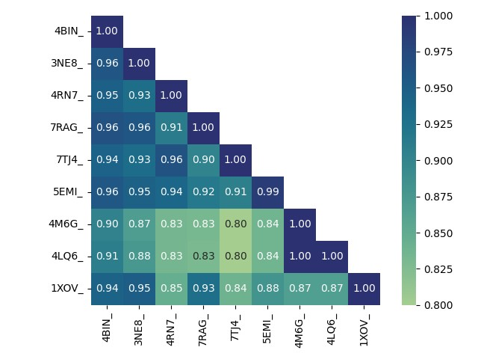

**B**

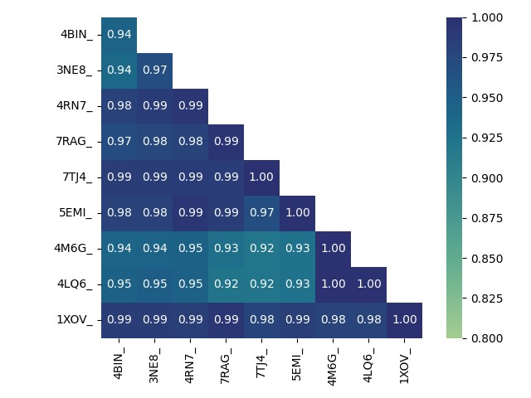

## Appendix E: Full Logo for the final Multiple Sequence Alignment

WebLogo displaying conservation across the entire multiple sequence alignment, including conserved and less-conserved regions. X-axis represents column of alignment. Y-axis represents probability of observing residue in that column (always sums to 1.0).

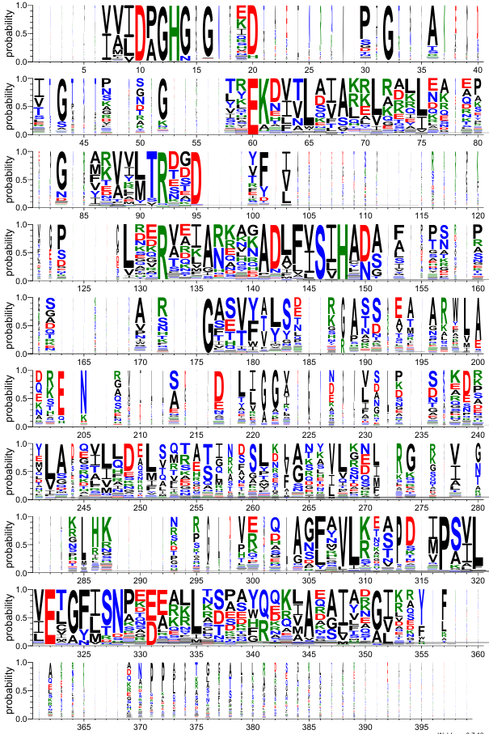

## Appendix F: Occupancy plots for each insertion region

Raw counts of per-species occupancy of regions I-1 to I-8, annotated by gram staining status. A=I-1, B=I-2, C=I-3, D=I-4, E=I-5, F=I-6, G=I-7, H=I-8.

**Bhhhhhhhhhhhhh**

**A**

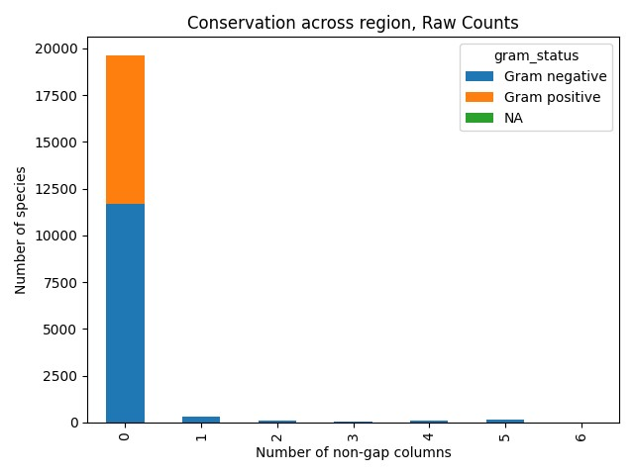 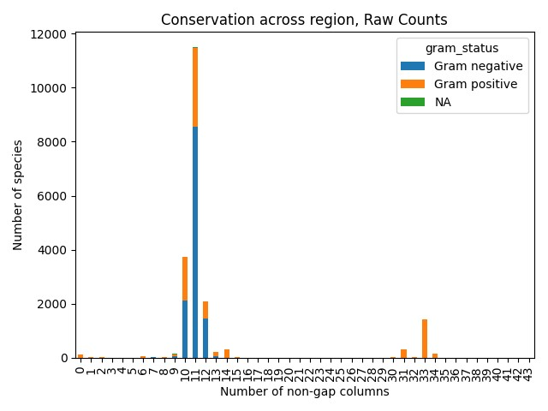

**C**

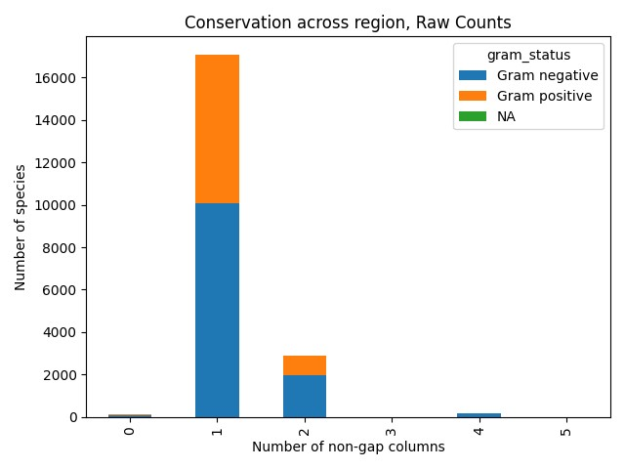 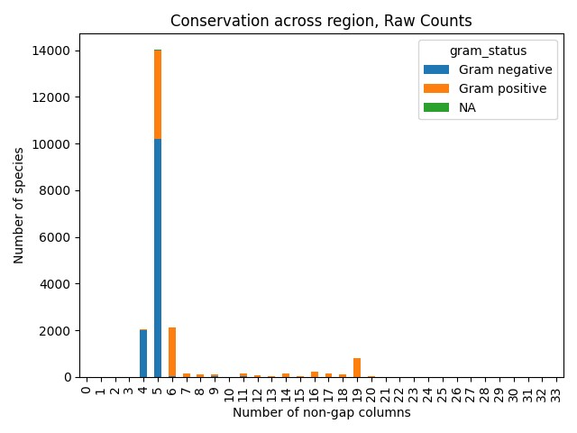

**D**

**F**

**E**

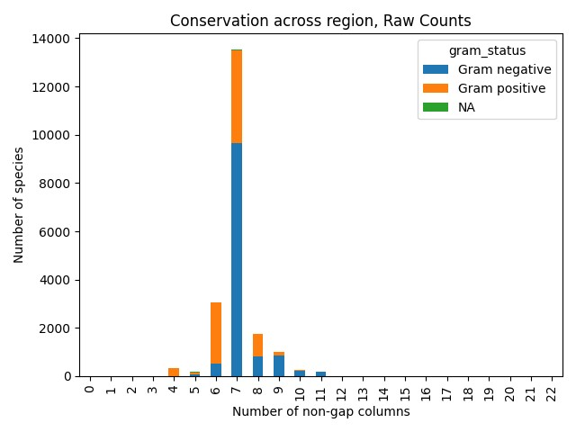 

 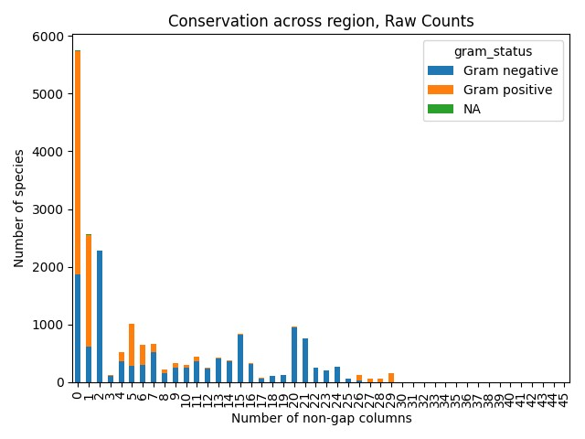

**H**

**G**

## Appendix G: PCA scatter plots for components PC1/PC3 and PC2/PC3

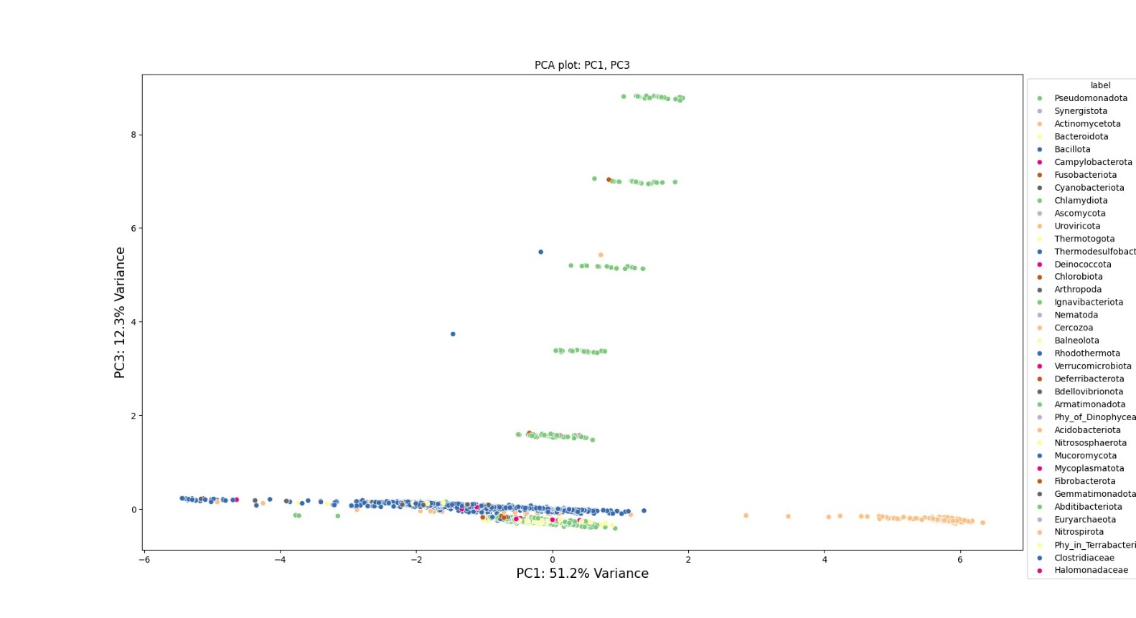

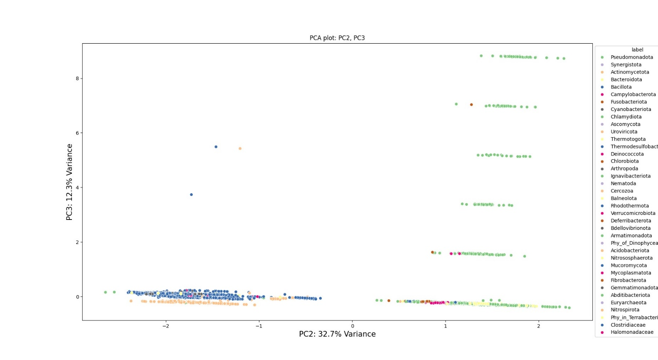

## Appendix H: Representative phylogenetic tree

Representative phylogeny for each unique combination of fingerprints comprised of the 8 predicted insertion regions seen across the sequence dataset. From innermost circle (dark blue) to outermost circle: I1 presence, I2 presence, I3 presence, I4 presence, I5 presence, I6 presence, I7 presence, I8 presence, Phylum (colour legend for phylum is below the phylogenetic tree). Full interactive tree can be accessed at: <https://itol.embl.de/shared/sallen>

